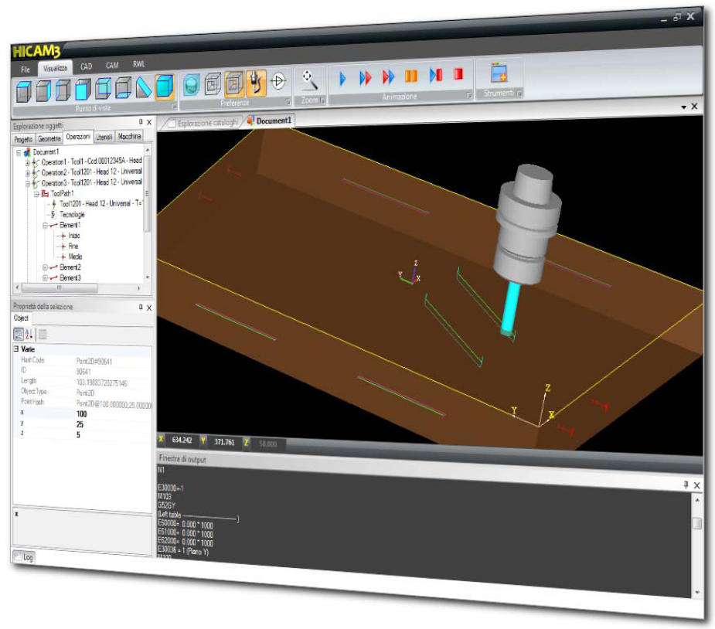
MU00201A08

rel. 1.0.0
05/10/2015

Installation and operation user’s guide

REVISIONS:
rev. | Date | info
1.0.0 | 05/11/2015 | First edition

PUBLISHED BY:
Autech di Fabbri Andrea
Via Fondo Ausa, 34 – 49781
Dogana – Republic. of San Marino
e-mail: info@autech-sm.com
web: http://www.autech-sm.com
Copyright  2007-2015 – Autech
All rights reserved

IMPORTANT INFORMATION:
This manual has been designed to provide information relative to the use of Hicam3 software developed by the Autech company.
The information contained in this manual is the property of the Autech company and may not be reproduced or disclosed without authorization.
Autech cannot be held liable for incorrect use of the information contained in the manual.

INDEX
1 INTRODUCTION 1
2 INSTALLATION 2
2.1 Pre-requisites 2
2.2 Basic installation 3
2.3 License activation 5
2.4 Installing optional Add-Ins 6
2.5 Directory structure and system files 6
2.6 Language support 7
3 PRELIMINARY INFORMATION 9
4 GETTING STARTED 12
4.1 The user interface 12
4.2 Units 16
4.3 Mouse 16
4.4 Keyboard 18
4.5 Global/Local Coordinates 18
4.6 Dialogs 19
5 THE WORKSPACE FRAMES 20
5.1 Main editing frame 20
5.2 Object explorer 20
5.3 Selection properties 22
5.4 Report window 22
5.5 Search result 22
5.6 Log 22
5.7 Command script shell 23
5.8 Tools 23
5.9 Output window 28
5.10 Save settings 28
6 THE STANDARD MENU REFERENCE 29
6.1 General 29
6.2 View 30
6.3 CAD 30
6.3.1 Create entities 31
6.3.2 WorkVolumes 33
6.3.2.1 Cubic WorkVolumes 33
6.3.2.2 Shaped WorkVolumes 34
6.3.3 WorkPlanes 35
6.3.3.1 Generic WorkPlanes 37
6.3.4 Edit entities 42
6.3.5 Automatic object snap 43
6.4 CAM 44
6.4.1 Tool selection 45
6.4.2 Tool radius correction 46
6.4.3 Geometries and ToolPaths 48
6.4.4 Routing operations 49
6.4.5 Blade cuts 52
6.4.6 Boring operations 55
6.4.6.1 Quick boring operations 55
6.4.6.2 Standard boring operations 55
6.4.6.3 Routed boring operations 56
6.4.7 NC program generation 56
7 APPENDIX - ALMACH 58
7.1 Profiles 58
7.1.1 Creating a new profile 58
7.2 Creating a new document from a profile 59
7.3 Creating machinings on a profile 60
7.3.1 The Machinings menu 62
7.3.2 Adding a Linear milling (example) 62
7.4 From drawing to ISO for CNC machine 64
7.4.1 Setting the machine configuration 64
7.4.1 Setting clamps position 66
7.4.2 Simulating a program 68
7.4.3 Creating the ISO file for the CNC machine 69
8 APPENDIX – HICAM3 PARAMETRIC FUNCTIONS 71

INTRODUCTION

Computer-aided manufacturing (CAM) is the use of computer-based software tools that assist engineers and machinists in manufacturing or prototyping product components and tooling. Its primary purpose is to create a faster production process and components and tooling with more precise dimensions and material consistency, which in some cases, uses only the required amount of raw material (thus minimizing waste), while simultaneously reducing energy consumption. CAM is a programming tool that makes it possible to manufacture physical models using Computer-aided design (CAD) programs.
The Hicam3 software, developed by Autech, is a CAD/CAM system dedicated to numerical controlled machining centers (in the following identified with the CNC acronym).
In modern CNC systems, end-to-end component design is highly automated using CAD/CAM programs: all part information are created by modeling programs (CAD =Computer Aided Design) which produce a computer file representing part shape and all dimensional information. This file is then interpreted by CAM systems to determine the commands needed to operate a particular machine. The CAM output is another file which includes any command, directive, instruction required to operate a specific CNC machine to produce the required part.
Sometime a prototype of the part is produced with special CNC equipment to generate a real sample of the part for evaluation and testing, but at a much lower cost respect to the “real” production process. This “rapid prototyping” process is especially useful and effective in industries (e.g. plastic, metal, ceramic) where the standard production process involves the development of expensive fixtures, molding forms, etc.
Similarly to other “Computer-Aided” technologies, CAM does not eliminate the need for skilled professionals such as Manufacturing Engineers and NC Programmers. CAM, in fact, both leverages the value of the most skilled manufacturing professionals through advanced productivity tools, while building the skills of new professionals through visualization, simulation and optimization tools.
Hicam3 is a highly customizable and flexible CAM solution which may be effectively exploited in a wide range of different applications, its powerful programming language enables implementing
“object intelligence” for a wide range of specific applications, yet keeping the overall system complexity for the end user very low.
The intrinsic 3-D nature of Hicam3 enables control of the most sophisticated machinery, while the fully programmable postprocessor makes it compatible with practically every control systems adopted presently and in the past.
The machining simulation provided by Hicam3 additionally allows for a complete program verification in software with collision detection, not only with the part itself but also with machine subassemblies and fixtures if properly programmed and configured.

INSTALLATION

The program installation follows a procedure similar to most Microsoft Windows programs and should be completed within a few minutes.
The program may be distributed on a media as CD-ROM, DVD, USB drives but also may be downloaded from Autech-Sm web site as a self-contained executable setup program.

2.1 Pre-requisites

To successfully install the Hicam3 application, most standard PCs fit well the task but anyway please check the following specifications are met.

HARDWARE:
- Any CPU Intel (Pentium 4, Centrino, Core2, Core 2Duo, Core2Quad, Core i3/i5/i7, etc.) or AMD (Athlon, Athlon 64, etc.) or compatible processor; as of every CPU-intensive application, overall performance depends heavily on the CPU capabilities: therefore a multicore processor is heavily suggested for best performance.
- 100 MBytes hard disk space (add another 280MByte for the .NET Framework if not yet installed on your system).
- 2 GBytes system memory (DRAM); 4GBytes are suggested for best performance.
- Any 3D-Enabled graphic adaptor (suggested model are Open-GL optimized boards as NVidia Quadro or ATI FireGL series); experience shows the most recent drivers, downloadable from manufacturers websites, often provide better performance and less bugs respect to the original drivers provided in the board retail box, therefore the user is always advised to check for latest drivers before installing Hicam3.
- In case the software must be installed from distribution media, a suitable CD-ROM or DVD drive is required.
- Any screen size is OK even if screen diagonals of 15” and more are suggested for best viewing.
- Any keyboard and mouse are OK. The Mouse is always required.
- To ensure the safest and most reliable operation, also an UPS (uninterruptible power supply) and some sort of backup media are highly suggested.
- A free USB port is required for the USB dongle provided with some systems (any low cost USB hub may be adopted to expand port availability on systems with few ports available).

SOFTWARE:
- Operating Systems: Microsoft Windows XP SP3, Vista SP1 or Windows 7 are supported. Please check if latest Service Pack from Microsoft is installed. It is also highly suggested to maintain the system updated by keeping active the on-line automatic updates service provided by Microsoft.
- All device drivers must be installed/updated before installing Hicam3.
- An antivirus software, kept regularly updated, is optional but highly recommended.
- The Microsoft .NET Framework 3.5 Service Pack 1 must be installed: to verify if it is already present please open the “Control Panel”, then the “Add/Remove Programs” applet and check if it is listed there. If not, please download it from Microsoft web site at following address:
http://www.microsoft.com/downloads/en/default.aspx
Then install it before proceeding with Hicam3 installation. Please consider the full download is about 240Mbytes, therefore an high-speed ADSL connection is highly recommended. The installation package for the .NET Framework is included in the Hicam3 distribution media so this download is not required if installing from CDROM / DVD.

2.2 Basic installation

The installation procedure is straightforward and requires just a few clicks.
At first, in case the .NET Framework was not previously installed, proceed with its installation.
There are 2 options:
- install it from Microsoft web site
- install it from Hicam3 distribution media
The first option is required when the Hicam3 distribution is downloaded from Autech-Sm web site or obtained as a single setup package: it does not contain this .NET Framework so it must be obtained directly from Microsoft download center. Should this case be followed, please follow
strictly the instructions provided directly by Microsoft on its web site and thru its web-installer.
In the second case, the Framework is provided as a single executable installer. Please open a Windows Explorer window and then find on Hicam3 media the file “dotnetfx35.exe”, double-click
on it to start the installation procedure and follow all on-screen instructions. At the end, reboot the system if required.
The actual Hicam3 installation package can be launched by double-clicking on file “hicam3_full_nodotnet.exe”. As for any common Windows application, the setup procedure asks for a few options (application home directory, etc), normally the default settings are just fine, then completes its operation in just a few instants.
In the following pictures the standard Hicam3 setup dialogs and settings are shown to help the user in the installation process. The first dialog just prompt the user to confirm the licensing agreement. Click on “I Agree” to continue the installation, otherwise it will be aborted.

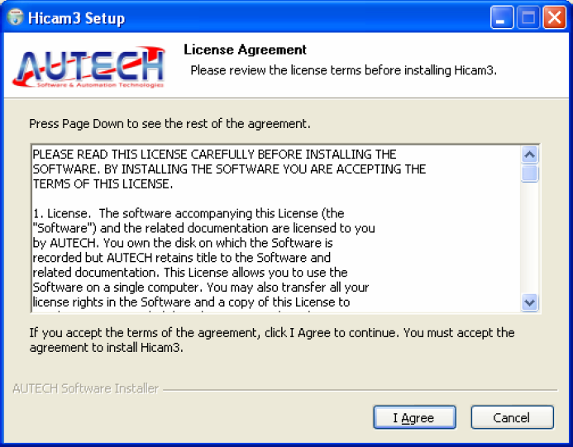

Then a second dialog is shown with the latest distribution information: please read carefully the
text shown because it contains the latest release information, not included in this manual.

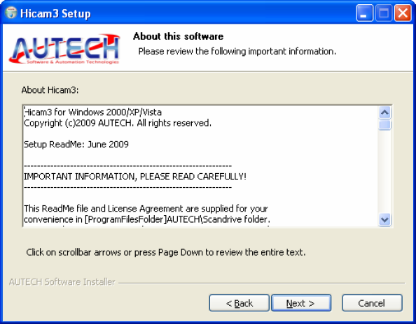

Third: the application home directory is by default pre-set to C:\Program Files\Autech\Hicam3 but the user may freely change this setting by entering directly the new path in the field or by choosing it with the “Browse” button.

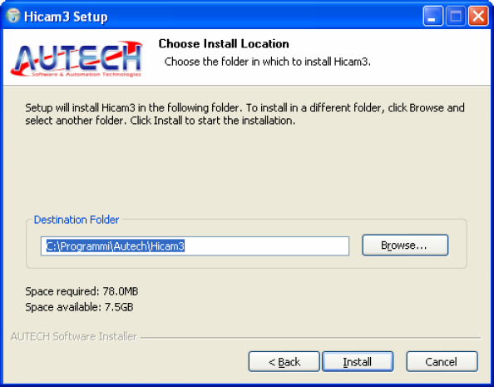

All settings are now done and the installation process will start immediately after clicking on the corresponding button. At the end just click on the “Finish” button to exit from the setup procedure.

2.3 License activation

To run the program the license must be validated by the original releasing company, Autech-Sm. The activation code enables the system execution on the PC it is installed on but may prevent it to run on different PCs simultaneously.
The product activation is a simple process and is done in 2 simple phases:
- A hardware identification code is generated on the PC where the software is intended to run: this code must be sent to Autech-Sm together with the product registration (normally by e-mail but also it can be faxed or dictated by phone).
- As soon as possible the activation code will be returned to the user in the same way.
The activation code may be temporary (defines an expiry date after which the product will not be anymore operative) or permanent according to the licensing agreement between the end user and Autech-Sm. For further reference please check with product invoice and/or order confirmation where the license type is explicitly defined as well as any other optional add-in module.
The first time the Hicam3 application is started, the dialog box shown in the following figure will appear prompting the user for the activation code.

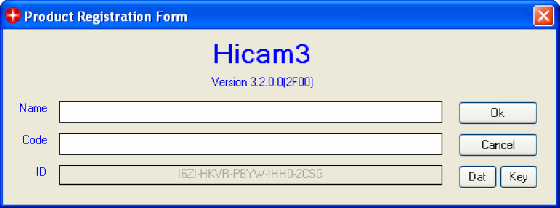
On installation featuring an USB dongle, the activation code depends from a key stored on the dongle itself, therefore the code is normally delivered with the key itself and may be installed on an arbitrary amount of different PCs yet only the one where the dongle is present will allow the application to run.
On systems without a dongle, the activation code depends from the actual PC hardware therefore it is valid for that one single PC exclusively. In case some hardware parts are replaced, then a new code must be requested to Autech-Sm specifying the reason of the request. Normally a new key will be granted upon payment of a fee.
In case the system was activated with a temporary activation code, at every start-up it shows how many days are left before the license expires. The user is advised to contact Autech-Sm at least 4 weeks ahead of license expiry date to get a new code on time.

2.4 Installing optional Add-Ins

Being the Hicam3 system highly configurable, beyond the standard installation package previously described, one or more add-in packages may be delivered to the user as separate archives.
The installation procedure for these add-ins takes place normally by copying the files directly in the proper directory: all add-ins are installed in a specific directory which is normally:
C:\Program Files\Autech\Hicam3\AddIns\User
The standard naming convention adopted by Autech-Sm assigns a 3-letter name to any add-in developed for customer, where these 3 letters are an acronym to define the application itself.
An arbitrary amount of add-ins may be installed on any system, yet each one normally requires its activation code which must be entered exactly as happens for the main application one.
Please refer to following chapters and to appendix for more detailed information about add-ins.

2.5 Directory structure and system files

All application files are stored in a directory sub-tree spanning from the application home directory selected during the setup process.
In this chapter the main application directories are shown exclusively for user reference, with the purpose to provide the user a better understanding and control on the software.
Normally, no operation shall be done directly on these files, unless explicitly advised by Autech-Sm.
00In the home directory only a few files are stored:
- ProgramInfo.txt – The read-me file shown during the setup procedure
- SoftwareLicense.txt – The licensing terms and conditions shown during the setup procedure
- Uninstall.exe – The program required to completely uninstall the application from the System
Within this directory there are a number of subdirectories:
- AddIns – All menus, commands, user functions and macros are stored here
- Bin – All program executable files, DLLs, etc.
- Cfg – The main application configuration file
- Tools – All tool configurations are stored here
- Works – Aux files and settings may be stored here.
The AddIns directory plays a crucial role in the system capabilities and functions and some deeper look is required; it includes 2 main subdirectories: System and User.
The organization of these subdirectories is identical, yet the first is reserved to Autech-Sm and no change should ever done to any of the files stored in it. The second instead is provided to host the user macros, customizations, etc. and any optional module provided by Autech-Sm itself or by dealers, 3rd party programmers, etc. shall be stored here.
AddIns\System contains all commands, menus, dialog provided as a standard with every system. The System.Ldr file is read at every program start to determine which of the installed modules shall be started. Only the ones listed in this file will be loaded and run, any other will be just ignored.
AddIns\User work pretty much in the same way, the User.Ldr file defines which of the modules
(subdirectory) stored into this directory should be loaded and run.
Each add-in module may be given any arbitrary name, but Autech-Sm adopted a naming convention to identify every module with a 3-letter name (with only a few exceptions in the System directory).
To provide and easy and quick way to disable undesired modules and functions, without actually deleting the files from the hard disk, any module (subdirectory) whose name begins with a “.” (just a dot) is always ignored.

2.6 Language support

Every text and label on screen in the Hicam3 software may be shown in foreign languages and the system supports virtually every language available on Microsoft Windows systems.
The 3-letter extension adopted for the message files must be thoroughly followed thru all system.
All main application language files are stored in the subdirectory:
… \Hicam3\Bin\Lng
For every Add-Ins, both in the System as well as in the User sub-directories, there’s a
corresponding language subfolder in its local directory. Example:
… \Hicam3\AddIns\System\Cad\Lng

… \Hicam3\AddIns\User\<AddInName>\Lng

Within each of these directories, all text and messages are divided into 2 main files:
- Labels.<lng> Menus, labels, dialog boxes names and controls, any text normally shown on application
- Messages.<lng> - Error and diagnostic messages
Where the extension <lng> should be replaced with the actual language code chosen. Standard
Extensions (in alphabetical order) are:
Cn - Chinese
Dk - Danish
Deu - Deutsch (German)
Eng - English
Fin - Finnish
Fra - French
Hun - Hungarian
Ita - Italian
Jap - Japanese
Ned - Dutch
Nor - Norwegian
Pol - Polish
Por - Portuguese
Rom - Romanian
Rus - Russian
Spa - Spanish
Swe - Swedish
Every system comes with Italian as well as English languages pre-installed. Others may be according to the actual country the system is delivered to.
A new localization may be easily arranged on the field by copying the pre-installed language files, keeping the same file name but with the desired extension.
Each message file is a standard Unicode text file where every text is stored on a single line as in the following example:

Document.OFD.Title § Open Hicam project file
The text on left of the special character “§” is the label key and shall never be modified. The text
on the right until end of line is instead the actual label and must be converted in the desired language.
As a general guideline for text labels, it is advisable to translate texts keeping the same length so far as possible, to prevent part of the text to be hidden and/or unreadable, and any unnecessary spaces should be removed, especially at the end of the text line.
Any line beginning with a semi-colon “;” is considered a comment ad is ignored.

Error messages may be of any length because the corresponding dialog is then automatically formatted.
As soon as all message files for a determined language are properly generated and stored in the corresponding \lng subdirectories, then the corresponding language becomes available thru the whole system and may be chosen in the configuration as the default system language.
If the translated files are e-mailed back to Autech-Sm (at the address specified in the colophon of this manual) they will be permanently integrated in future releases.

PRELIMINARY INFORMATION
In order to get the most from this document, at first the meaning of some terms, which will be
used in this document, must be explained.
At first, the manipulation of entities within the Hicam3 system will happen thru menu commands.
These are organized hierarchically and whenever a menu command is referred, it will be represented with the “hierarchy-path” the user must follow to access it from the main page, and it will appear in this manual as follows:
CAD > Create entities > Line between 2 points 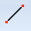

This writing means that this command is accessible by opening the CAD menu, then look for the
panel “Create entities”, and finally click on the icon in order to select the command from the appearing list.
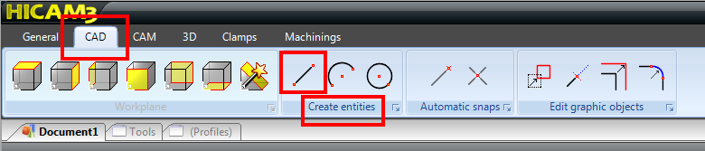

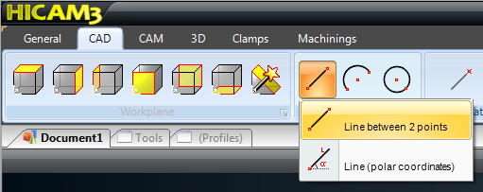

Even if most of the commands and the menu functions may be used with the keyboard only, the mouse has a crucial role in getting the most from the Hicam3 application: many of the commands described in this manual require some mouse operation and the reader is requested to properly understand the mouse operations according to the conventions adopted in this document.

On a mouse with the typical configuration, the left button is used as a Select tool. The right
button is used as an Alternate select tool. Some mice have a third button or a wheel.

With this typical configuration, if you see the word "click" used in this document, that means to click one time with the left mouse button on the object specified. A "double-click" means to click two times in relatively rapid succession on the item or object specified. A "right-click" means to click one time with the right mouse button on the object specified.
Also, you will be asked to "drag" objects with the mouse at certain times. This means that you will hold the mouse button over the specified object, click and hold the left mouse button, then move the mouse while still holding the left button until you reach the area that you were instructed to move the object to. Some objects may be "dropped" by simply letting go of the left mouse button.
Other objects must be "dropped" by clicking again when you reach the destination. This will be
something that you will simply have to practice in order to master.

Third, when describing buttons on the keyboard, they will appear as images like this: .
If there is a sequence of buttons that need to be pressed, it will appear as follows:
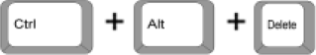
This type of sequence requires that the buttons all be pressed at the same time to get the desired result.

Next, this manual will sometimes refer to "pull down" or "drop down" menus. Those are both the same type of menu and will be evidenced by an arrow to the right of the selections that you will click on to expand the choices. Here is an example:

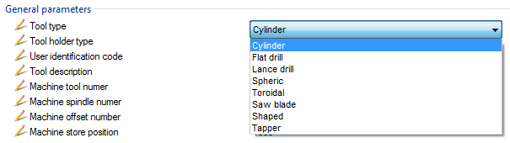

Some commands will require the user to input in the system point coordinates (2D: X and Y, or 3D: X, Y and Z). This operation may be generally performed by clicking on the screen but also these coordinates may be typed in directly as decimal values. There will also be references to numeric entry in these help files. In the help files, numeric entry will look like this (0,0). The numeric entry in Hicam3 is located on the bottom of screen and will look like this:

Coordinates will be entered in the standard Cartesian format, therefore the 1st number corresponds to the X coordinate, then Y and Z respectively. Each number will be entered into
Hicam3 in this, so in this instance, (50,100) would look like this:

You would then press the button , or click the icon , to complete this numeric entry.

GETTING STARTED

When using Hicam3, it is important to understand how to interact with the Hicam3 environment.
Hicam3 is a Windows application that allows you to create 'digital' elements that represent an 'analog' item that will be created, typically using a Computer Numerically Controlled (CNC) Milling machine.

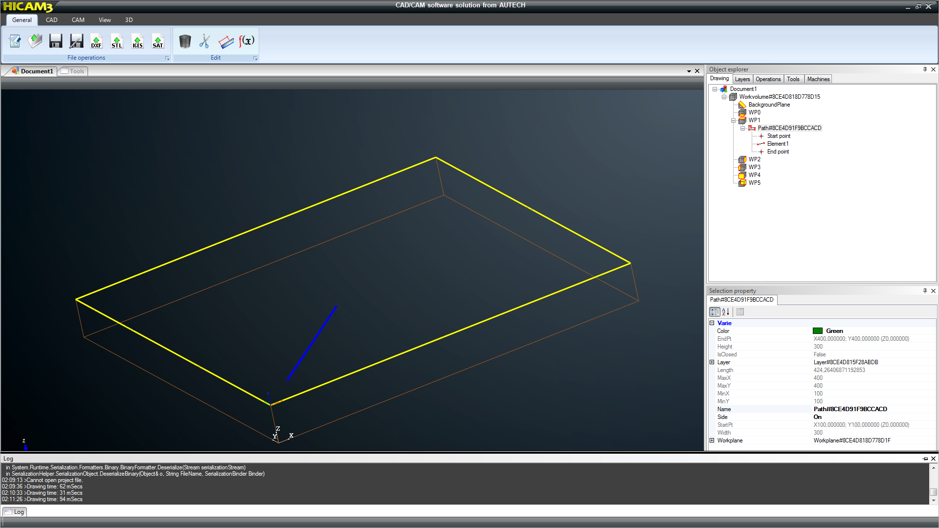

4.1 The user interface

The user screen may be ideally divided into 3 main areas:
The Title Bar. The small strip on top where the application name is shown as well as the 3 standard window control button on top right corner. Their operation follows strictly the standard Windows behavior.

The Ribbon. The Hicam3 system provides many different commands to perform any possible operation required for the various applications. More commands are then added with optional add-ons to perform specific operations.
All commands are organized hierarchically in groups. To maintain a consistent and logical arrangement, multiple “panels” are defined within any program group, where each panel includes one or more icons corresponding to individual commands belonging to the same logical function.
As a simple example, let look to the following picture which represent the ubiquitous General menu: it includes in the standard configuration 2 panels, one dedicated to the operations with files and the other to the interaction with the Windows clipboard and some utility.

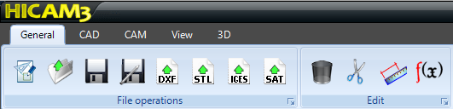

As in any standard Windows application, the File panel provides an icon for the following standard commands: New, Open, Save, Save As…, Import from DXF file; the Edit panel instead provides as a standard 2 icons for the commands: Clean Up, Cut.
Three additional menu groups are provided in the ribbon above: “View”, “CAD”, “CAM” (they will
be described later in this manual).
To show the panels belonging to each group simply click on the group name in the upper row and immediately all panels and icons belonging to it will be shown in the main row just below.
Commands not available or disabled in the current operating mode will be represented “greyed
out” and no operation will happen when clicking on them.
If the mouse pointer is left still on any icon for a short time, a tooltip will show up with a short
description of the command operation and purpose.

The workspace

The main screen area can be freely arranged by the user to host a number of different frames each one with its own purpose. Not every frame may be required for every specific application so the user is able to freely choose the arrangement which fits best the job.
In the picture below the standard workspace arrangement is shown:

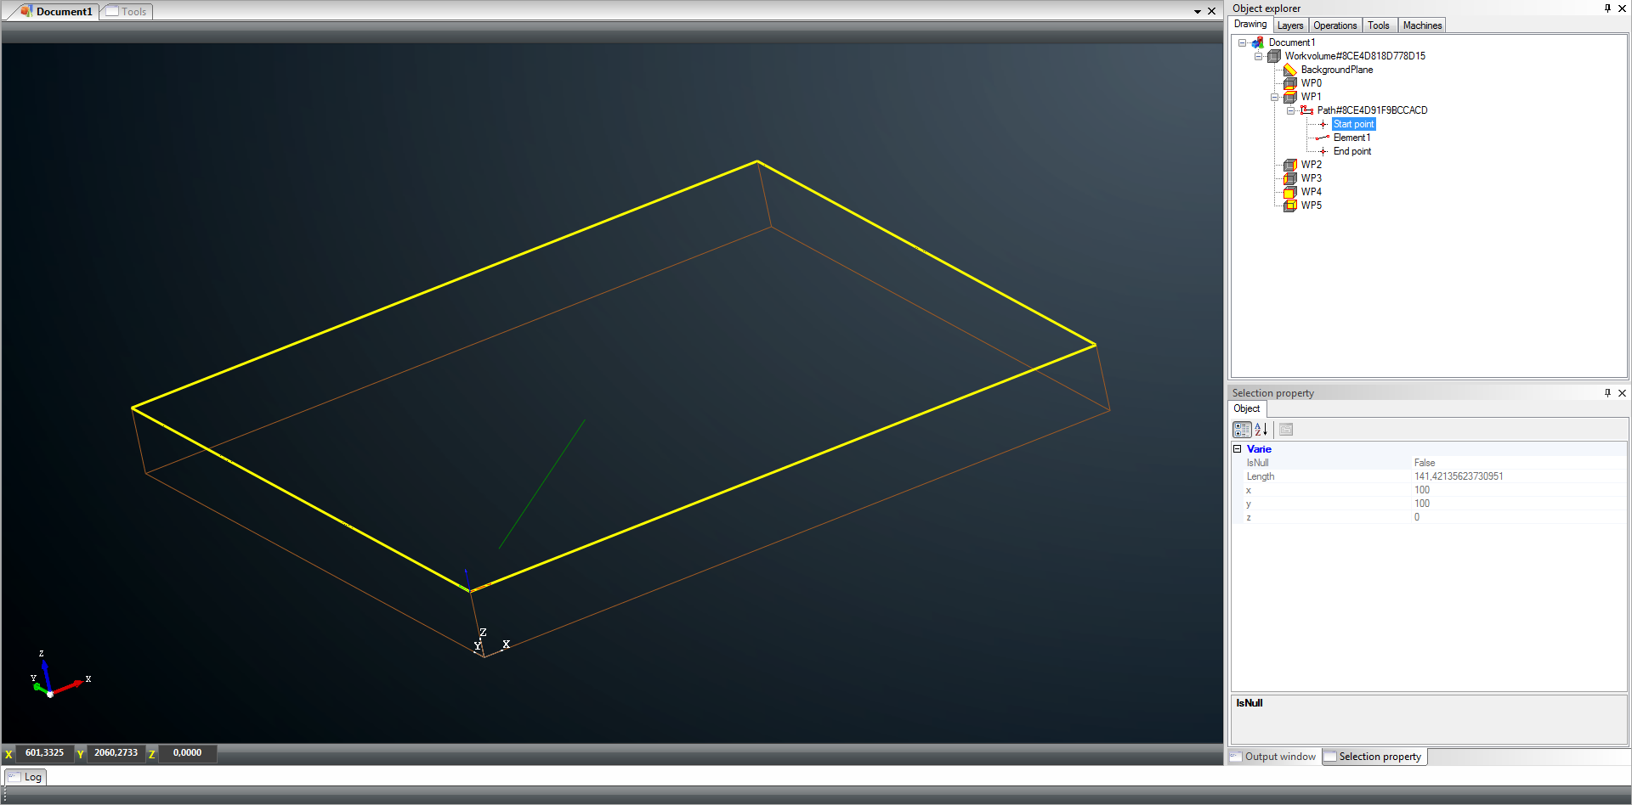

This layout features the following frames:
- Main editing frame, composed by two different sub-frames: the Document tab and the Tools tab. Both may be detached and made independent frames.
- Object Explorer
- Selection Property
- System Log
- Output window
All these frames may be “docked” or left “afloat” on the workspace, hidden or shown, according
to user preference and operational needs. By left-dragging the frames titles the user may freely
rearrange the workspace and the system will “remember” the user preferred setting so the next
time Hicam3 starts all frames will get back to the positions set by the user. Specific settings optimized for a certain task may be saved on disk to be recalled later.
The following picture represent the application workspace while dragging the Selection Properties window over the main editing frame: please note the “docking indicators and central diamond” used to control the various docking options available. If the left mouse button is released when the pointer is on one of the “docking indicators”, the corresponding docking action will be performed.
The new size and position of the dragged frame will be shown with a transparent blue rectangle.

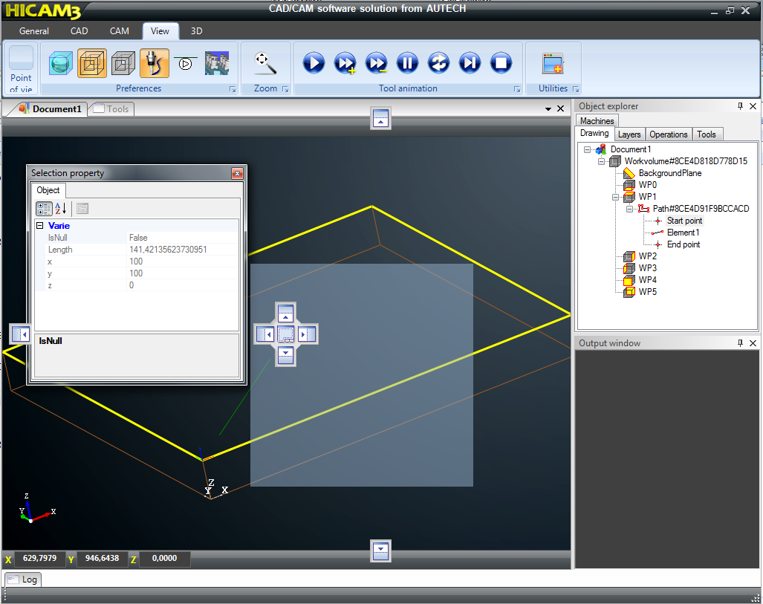
If the mouse left button is released on these “side docking indicators” points, the frame being dragged will be “docked” on the corresponding side of the main editing frame, and it will extend over ¼ of its height / width.
The “log” frame was docked on the bottom side and its “auto-hide” pin was “released.
This is the “docking diamond”: the 4 “indicators” work similarly to the other ones close to the margin but in these cases the docked frame will extend by ½ of the height/width. If the left mouse button is released instead when it is on the central “tabbing” indicator, then the dragged frame will become a “tab” of the main editing frame. In this figure, the “Tools” control was already “docked” as a tab in the main editing frame.
The frames on left are docked on left side of workspace. Their “auto-hide” pin was left down so these frames are always visible
This is the original “Selection property” frame position, floating on screen (not docked) in the foreground.

The user is advised to get accustomed with these commands and controls because the user interface may be completely customized for any different need.
The overall product usage may become much easier and quicker if the user interface is properly tuned to the job to be performed.
All frames may be freely enabled and disabled, left “floating” or “docked”, different frames may be “grouped” as tabs of a single frame, the auto-hide feature allows to keep on screen just a small tab, freeing up precious screen space for the main editing frame, but the corresponding frame may be opened with just a mouse click and then hides itself automatically after a short delay (this feature is useful especially for the log and output frames).

Finally, every single frame may be closed and opened with the following menu command:

View -> Utilities

Which will trigger the following pull-down menu. All supported frames are listed here and each
one can be individually turned on / off by clicking on the corresponding row.
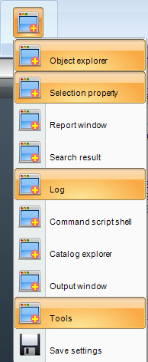
By clicking on this icon the current settings are saved on disk and will become the default screen layout at startup.
A white background means the corresponding frame is turned off and will be shown after clicking on this line
A colored background means the corresponding frame is turned on and will disappear after clicking on the corresponding icon.

For a detailed description of the various frames listed in the figure above, please refer to chapter 5.

4.2 Units
All units used within Hicam3 are purely abstract and do not reflect necessarily any specific measurement unit. As most CAD/CAM systems, Hicam3 adopts a decimal numbering system:
therefore, entering a value of 1 will give you 1 unit, entering .5 will give you 1/2 (one half) of a unit.
In most cases the Hicam3 unit will correspond to 1mm, but also any other one may be used.
Because of this, also “decimal inches” can be effectively used but legacy imperial units (fractional inches [e.g. 3/8”, 7/16"], feet [e.g. 3ft. 5”] and yards ) are not supported.

4.3 Mouse

The Mouse has several different functions in Hicam3 but follows the same principles of operation seen also in many other windows programs.
Generally speaking, the mouse is used to:
- Invoke menu commands and functions
- Confirm or cancel settings in dialog boxes
- Select items on the graphic screen
- Change the graphic view by zooming, rotating, panning.
All these operations are performed by moving the mouse on the proper items on screen and then by clicking in various modes on its buttons.
The operation performed will change according to the item pointed on the screen by the mouse pointer, but also according to the button pressed and eventually if any special key on the keyboard is also pressed with the left hand (right one for left-handed users) according to the following rules.

Left Mouse Button

A single click with the left mouse button will cause the following effect, according to the item currently pointed on screen:
Menu bar: Open the corresponding pull-down menu
Menu item: Triggers the operation according to the selected menu command.
“Ribbon” group label: Shows on the ribbon bar the icons corresponding to the selected group
“Ribbon” icon: Triggers the operation according to the selected icon.
Dialog box field: Put the focus in the selected field to edit its value
OK button: Commits all changes, which will become now effective. The dialog box will disappear
CANCEL button: All changes will be discarded and the previous values will remain effective. The dialog box will disappear
Other buttons: Similarly to menu items, the corresponding action will be initiated
Graphic entity on screen: In case a command was chosen with the purpose of editing the graphic entities in the drawing frame, the pointed entity will be selected for the active command (the entities which may be selected and edited depend from the active command).
Double clicking is not currently supported.
“Left-Dragging” (moving the mouse pointed by keeping the left mouse button pressed) is currently used only to displace the various panels of the user interface (see corresponding chapter)

Right Mouse Button

The right Mouse button has two default functions inside of Hicam3.
The first is to abort/complete the active command. For instance, if you are currently attempting to use the CAD | Modify | Move command to move an element from one place in the drawing to
another and you have not selected any element(s) to move, clicking the right Mouse button will abort the command. On the other hand, if you have select one or more elements to move, clicking the right Mouse button will continue the command to the next step.
The second is to enable the right-click menus available inside of Hicam3. When you right click on some items in the Object Explorer pages, a menu will be displayed that allows you either quick access to specific commands, or additional commands not otherwise available.
Central Button (Wheel)

The default action that takes place when you click the middle button is zoom. Moving the mouse up by holding the middle button will cause the selected view to Zoom In, or make the drawing larger. Moving the mouse down by holding the middle button will cause the selected view to Zoom Out, or make the drawing smaller.

4.4 Keyboard

The keyboard in Hicam3 can be used in various ways. One way is to enable shortcuts using simple keystrokes. The keyboard allows you to enter text and numbers into the application.
When you are using a command, at the bottom of the screen one or more boxes will be present.
These boxes allow you to enter coordinates (when using the CAD | Drawing elements | ... command).
Pressing the key on your keyboard allows you to jump to the different text boxes as well.
You can also complete/abort a command by pressing the key on the keyboard.

4.5 Global/Local Coordinates
Hicam3 uses two types of coordinate entry, Global and Local.
Global coordinates allow you to enter X, Y and Z coordinates that are based off of the drawing view's X 0, Y 0, and Z 0 coordinate point:
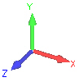
Local coordinates allow you to enter X, Y coordinates that are based off of the selected Work Planes Origin point. The selected Work Plane's origin point is also labeled as X 0, Y 0.
Typically, CNC machines use global coordinates to determine the positioning of the tool, table, or other moving objects, based on it's own fixed reference point. Because of this all coordinates that are entered in Local entry, will be converted into global coordinates when a Work Plane is not active.
Global and Local coordinates operate on a typical Cartesian grid system:
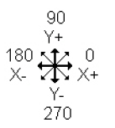

4.6 Dialogs
When using Hicam3, you will may use dialog forms to enter information into the application.
Dialog forms come in two styles, Modal, and Non-Modal.

A Modal dialog is a dialog that takes focus from the application and does not allow you to continue until all changes done to the fields in the dialog are either cancelled or confirmed.
In other words, when a modal dialog box is shown, the user may change any of the fields shown in the dialog itself according to current needs but, most important, must either click on the Cancel or on the Confirm button, respectively to abandon any change done (and to continue using old values) or to commit changes (and going on with the new values). An example of a modal dialog in Hicam3 is the Parameter editor dialog:

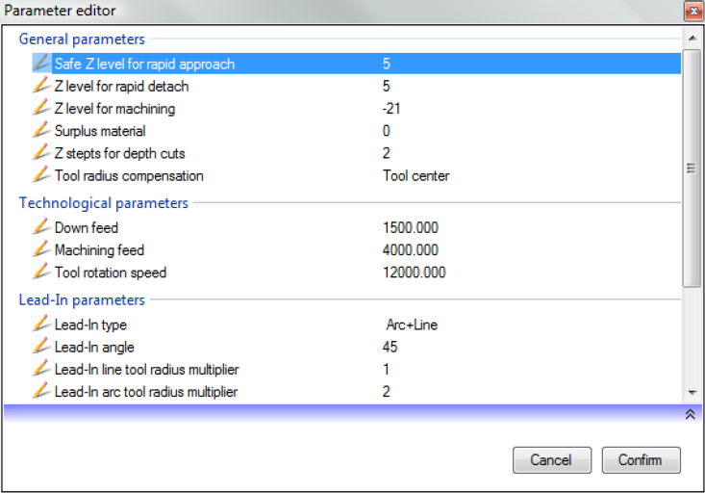

When this dialog is displayed, you must, either, fill out the appropriate information and click the Confirm button, or click the Cancel button to continue with the normal operation of Hicam3.

THE WORKSPACE FRAMES

Each of the frames shown in chapter 4 has a different purpose. And will be presented in detail in this chapter.
Some of the proposed frames are always required, as the main editing frame or the object explorer, but others may be required only for specific purposes and are not normally used in the basic package.

Main editing frame
The main graphical screen is where the drawing database is shown, according to the various display options chosen in the View menu.
According to the active command, entities may be selected in this frame for editing (alternatively
numerical input boxes are shown on bottom of this frame).
Whenever an object is selected it is highlighted (its color is changed to identify which object was
selected).
The standard color scheme is as follows:
- White – Geometries under mouse pointer… will be selected if left-clicked. Works only
when a command is active prompting the user to select one or more geometries.
- Yellow – The current WorkPlane boundary (intersection lines with container WorkVolume) and its local axis. This color is used also to represent the geometry being built, before final confirmation.
- Green – 2D Geometries
- Brown – The edges of WorkVolumes
- Blue – Any selected geometry
- Cyan, Pink, Red – ToolPaths (different tools)

Object explorer
The Object Explorer displays the content of the drawing database.
Hicam3 exploits a flexible object-oriented database and drawing entities are arranged in an hierarchical structure.
The object explorer allows the user to monitor the complete drawing database and shows all relationships between objects.
These are furthermore divided into multiple tabs (and the tab structure may be expanded by optional add-on packages) for a better understanding and control of the project database.
The following picture shows a typical view of the object explorer for a sample drawing: the “father” object is the “document1” (actually the current filename will be shown, after the job is saved under a given name).
Any project may be composed by one or more WorkVolumes, roughly corresponding to the raw part sizes (before machining). A WorkVolume is in most cases just a cubic 3D object but it may also be obtained by an extrusion process from any 2-D closed curve on the XY plane.
Within each WorkVolume, an arbitrary amount of WorkPlanes may be defined (some are predefined as the external faces of the WorkVolume). Any WorkPlane has its local origin and is also defined by the axis rotation of its local XYZ axis respect to the global ones.
On any WorkPlane (WP) an arbitrary amount of Geometries (or Paths) may be defined where a Geometry (Path) is a sequence of elementary drawing entities (lines and arches).
Each object shown in this frame is defined by a certain amount of properties, which will be displayed in the “Selection Properties” Frame.
All this object structure is then displayed in a tree form to let the user identify immediately every object in the drawing and its relationships with other objects.

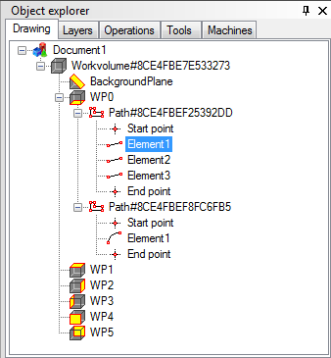

By clicking on any object in the tree it will be selected and the content of the “Selection Properties” frame will be immediately updated but also the corresponding graphical object will be highlighted in the main graphical editing frame as shown in the figure below.

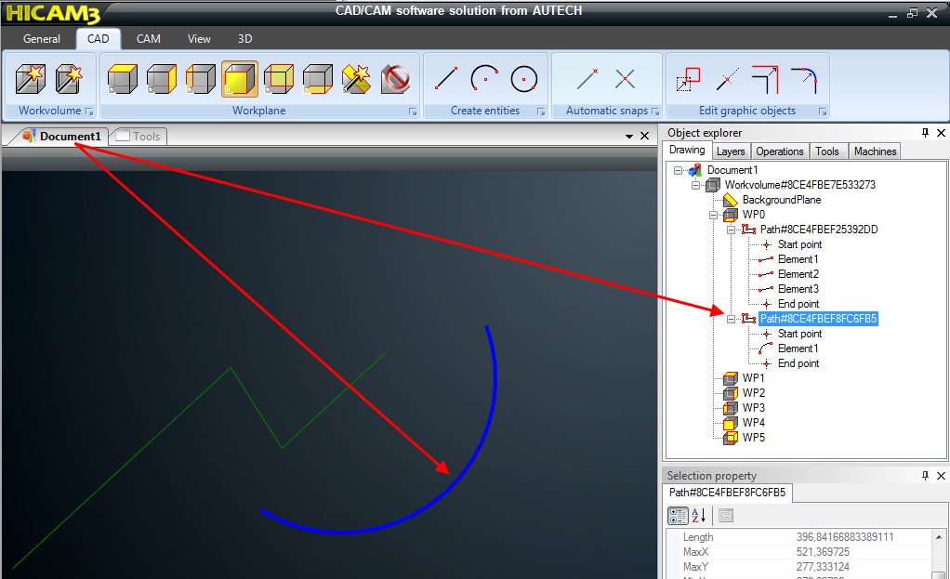
In the above example you can see how the arc will be highlighted when the item Path#8CE4FBEF8FC6FB5 is clicked on the Object Explorer.

This frame is made with multiple tabs to represent different kind of objects:
- The Drawing tab includes only CAD objects (Geometries and their elementary entities).
- The Layers tab includes each CAD layer created.
- The Operations tab includes only CAM objects (ToolPaths and their elementary entities).
- The Tools tab list all tools used by current project
- The Machine tab is used only when the optional machine simulator module is installed and represents the solid object structure of the machine for which the program is created.
- Other Object Explorer tabs may be created by AddIns modules: see their respective documentation for further reference.

Selection properties
As previously explained in the previous chapter, this frame displays the properties of the currently selected object.
This frame is read-only and these properties cannot be modified here.
The main purpose of this frame is mainly for diagnostics: any possible typing mistake, inconsistency, incoherency, etc. can be easily identified and tracked down in this frame.

Report window
Not used in the basic application. It is provided for add-in modules. Please refer to their documentation for additional reference.

Search result

Not used in the basic application. It is provided for add-in modules. Please refer to their documentation for additional reference.

Log
Every operation performed on system normally generates some log messages. Add-In modules may exploit the log feature for debugging and diagnostics: because of this the log file may become really big and therefore the mechanism of the “log level” has been implemented to limit it only to really useful information.
The following picture represent a typical log frame after right-clicking with the mouse in it: the right-click-menu is shown which provides three main functions:

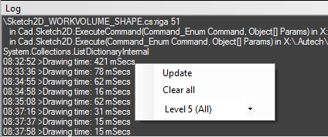

- Update – Refreshes all messages on screen
- Delete All – Erases completely the log message screen and restart it from scratch
- Level N – Set the logging level to the desired value. Whenever a command is executed, it will generate logging messages to keep track if its operation (mainly for debugging purposes). To prevent the log file to bloat to unmanageable sizes, the proper logging level may be set.
There are 6 Predefined logging levels, being the 0 the lowest-detail level and 5 the highest-detail one. The user may set the level to the preferred one to get only relevant information for his need and to filter out all unnecessary messages.
Levels are predefined as follows (guideline to programmers):
0 – System critical error messages
1 – System warnings and non-blocking error messages
2 – Startup messages and other service information
3 – Generic messages by Add-In modules
4 – Parameters passed to methods in Add-In modules
5 – Intermediate calculation in methods in Add-In modules
Whenever the user set the log level to any value, only messages flagged to be of that or lower values are shown, all other messages are simply discarded and are not stored in the file.
This setting is preserved also after system shutdown, the next time Hicam3 starts up it will keep current logging value.

Command script shell
Service frame reserved to 3rd party programmers. Not intended for normal product use.

Tools
This is the main Tools configuration window. All tools which may be used to generate any machining must be previously declared here.
Add-In modules may also provide special function to import the tool information from other sources, the standard package provides only this frame to configure all tools.
The following figure represent the catalog explorer frame in a typical system: some tools have been configured and the record of the first one is being edited.
The frame layout is divided in 4 main areas:
- On top left corner, a fast search box where a tool number may be entered to quickly access its parameters: just type in there the required tool number (assuming it is known) and immediately after confirming with <Enter> its parameter will appear in the main screen area.
- On top right corner, there are 3 buttons: Add New Tool, Delete Tool, Activate Tool.
- Add New Tool: a small box will pop up prompting for the number identifying the new tool, pre-loaded with the first free number. The tool number here assigned is valid only within Hicam3 and does not affect neither the number given to the tool on machine neither the slot on tool storage it is loaded on.
- Delete Tool: its file will be simply deleted from disk and therefore the tool will be permanently removed from the system
- Activate Tool: a 3D representation of the tool will be displayed on the main editing frame, perpendicular to the currently active WorkPlane, prompting the user to confirm the selection with a left-click. From this moment on, all new machining will be generated with this tool. Otherwise, with a right-click, the tool activation will be aborted and the previous one will remain active. The tool representation depends from the viewing mode: perspective 3D or orthogonal faces.
- On left side, an icon is shown for every tool present. By clicking on a tool icon, its parameter will be immediately shown in the main frame area on the right. If more tools are present than the visible ones, the icon list can be easily scrolled by dragging it up-/downward with the mouse… faster the dragging, quicker the scrolling with a sort of free-wheel effect (inertia).
- The main frame area is dedicated to the currently selected tool parameters. By clicking with the mouse on any one of them, its value may be edited. After confirming with <Enter> the new values are immediately saved on disk.
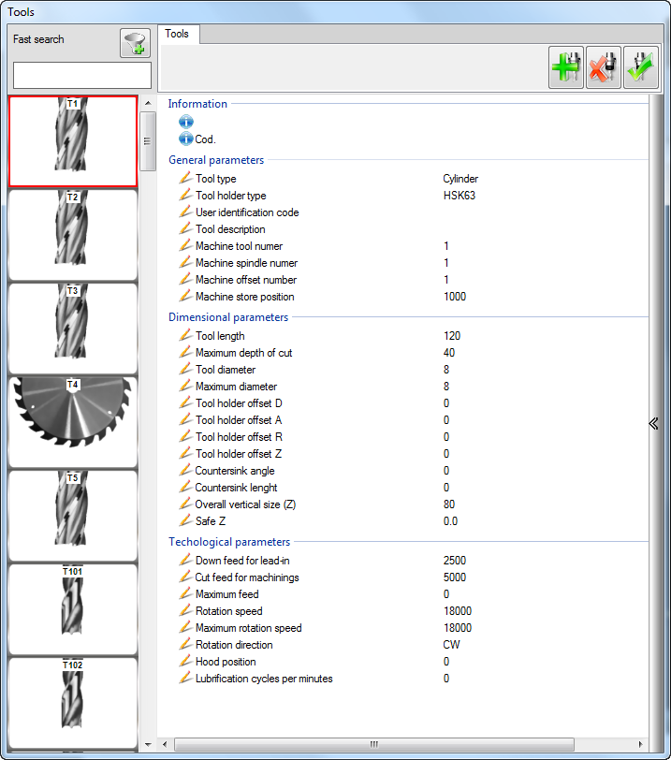
Buttons to create new tools, delete existing ones and activate current tool.
Configured tool list.
When available tools
icons extend beyond
this space, the list can be browsed by dragging the icons vertically.
Quick search field: just type in desired tool number and its properties are quickly shown in the editing area.
Tool parameters editing area.

General parameters:
Tool type – May be any one of the types listed below. According to the selected type, certain
machinings may be disabled or differently calculated.

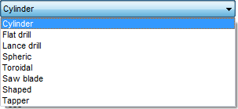
Cylinder (finger tools) Any kind of drilling or routing is allowed.
Flat drill – This tool is normally used only for blind bores. Only boring operations (standard or deep/pecking) are allowed for flat type drills.
Lance drill – This tool is normally used only for pass-thru bores. Only boring operations (standard or deep/pecking) are allowed for lance type drills.
Spheric – This tool can be used for 3D 3-axis surface machinings only (tool-tip machinings with contact point calculation).
Thoroidal – This tool can be used for 3D 3-axis surface machinings only (tool-tip machinings with contact point calculation).
Saw blade – Can be used only for straight cuts.
Shaped – Similar to cylindrical routers, the only difference is that their shape may be defined with a DXF file and the part simulation will then reflect the actual shape of the tool.
Tapper – Tapper tools are intended for tapping operation to be performed after drillings.

Tool holder type – There are 3 pre-defined tool holder types: None, HSK63, Rigid HSK63. If a tool holder is chosen, it will be represented in the part simulation together with the tool geometry
thus allowing program verification also considering potential collisions between tool-holder and parts and/or machine.
User identification code – Any user-chosen alphanumeric arbitrary length code identifying the tool. This may be useful when interfacing Hicam with any external tool management software.
Tool description – Any user-chosen alphanumeric arbitrary length code which properly describes the tool. This description is normally printed in CNC machining program.
Machine tool number – Tool number which shall be printed in CNC output program. Example: if this tool is given the Hicam3 internal number 123 but in machine program should be written as T=1123, then this field may be set as “1123” to generate this number in the output CNC program.
Machine offset number – Tool length corrector (in corresponding table on machine CNC) to be declared when the present tool is used. This setting comes especially helpful on old equipment where the correctors table is separate from the tool database.
Machine store position – Number of the slot, pocket, clamp where the current tool is normally parked on machine. This value may be required or not according to the machine specific NC system, please refer to machine manufacturer and/or postprocessor documentation for further reference.

Dimensional parameters:
Tool Length [mm] – Amount used for the tool length compensation, normally along the Z axis.
The machine postprocessor may be programmed to use the tool length set in the tool table on
machine NC or alternatively this value: please refer to postprocessor and machine documentation for further reference.
Max cutting depth [mm] – Every tool is characterized by a maximal cutting depth which depends both from the cutter length and from its capability of removing chippings and dust from the cutting area. This parameter must be set to the maximum cutting depth achievable by the tool in every expected operating condition. This doesn’t mean the tool cannot machine any deeper:
provided the tool holder and shaft are long enough, deeper cuts are achievable by splitting them in multiple passes each one respecting this amount.
Tool diameter [mm] – Amount used for the tool radius correction for routing tool paths. The machine postprocessor may be programmed to use the radius set in the tool table on machine NC or alternatively this value: please refer to postprocessor and machine documentation for further reference.
Max tool diameter [mm] – For cylindrical router the tool diameter normally corresponds exactly to the external diameter so there’s no need for a second redundant parameter. For shaped routers, instead, the tool diameter used for the radius correction is smaller than the overall diameter of the physical tool, and this one should be used in calculations for lead-in and lead-out paths to ensure full detaching of the tool from workpiece. Make sure this parameter is set to the overall tool diameter for a proper calculation of these auxiliary geometries in tool path.
Tool holder D offset [mm] – Parameter used when the tool is mounted on an angular gearbox. Leave it to 0 in case of plain vertical tools. Please refer to following pictures about proper setup of this parameter.
Tool holder A offset [mm] – Tilt angle of angular gearbox, to be set only when the tool is mounted on it. Leave it to 0 in case of plain vertical tools. Please refer to following pictures about proper setup of this parameter.
Tool holder R offset [mm] – Horizontal angular offset of angular gearbox, to be set only when the tool is mounted on it. Leave it to 0 in case of plain vertical tools. Please refer to following pictures about proper setup of this parameter.
Tool holder Z offset [mm] – Parameter used when the tool is mounted on an angular gearbox. Leave it to 0 in case of plain vertical tools. Please refer to following pictures about proper setup of this parameter.
Countersink angle [deg] and length [mm] – These parameter work only for drills when a countersink cutter is fitted on them. They are intended to determine automatically the boring depth to align the countersink shoulder with material surface. See following picture to see exactly how to set these parameters.
Overall size (Z) [mm] – Set this parameter to the overall vertical tool size, considering also possible mechanical devices extending below the cutter. This is particularly important for large shaped routers as the ones used in the door & window industry.
Safe Z [mm] – Safety distance which must be respected between the bottom end of the tool and
the workpiece surface.

Technological parameters:
Lead-In Down feed [mm/min] – Feed rate during tool lowering at machining level. This value must be set according to the operating mode expected for every tool: if the lowering at working level happens in “air” (far away from workpiece), then this speed may be kept as high as possible to save machining time. Otherwise, in case the tool may be lowered directly on workpiece, then a much lower speed shall be set to allow for proper chippings removal.
Cutting Feed for machinings [mm/min] – Standard feed rate for most common machinings. In case of doubt, set this parameter conservatively to relatively small values.
Max feed [mm/min] – Maximum feed rate allowed for present tool. This parameter must be set according to the tool type and the material which may be cut… being a limit value, this shall be the highest value allowed in any expected operating condition.
Rotation speed [rpm/min] – Standard spin rate for most common machinings.
Max rotation [rpm/min] – Maximum spin rate allowed for present tool. This parameter must be set according to the tool type and to the manufacturer specifications. CAUTION: If this parameter is not properly set there’s a potential risk for machine operators and for every other people in the machine surroundings: some tools (e.g. sanding tools) do not tolerate overspeed at all and may “explode” due to excessive spin, ejecting parts and debris at very high speed at great distance! Please set this parameter with the greatest care and never exceed tool manufacturer specifications!!
Rotation direction [CW/CCW] – Must be set according to the tool spin direction. No need to say wrong setting may result in serious damage to the tool, to the machine and to the workpiece
itself.
Hood position – This is an optional value which may be exploited by the postprocessor to control the dust extraction hood fitted on machine router head.

Output window

The output window is intended as a control frame for postprocessor output. When a CNC program is created, the postprocessor operation may be monitored here without the need to open the actual file created on disk.

Save settings
The frame docking options, dimensions, positions are permanently stored on disk and will be preserved after system shutdown. Any subsequent save operation will overwrite current settings.

THE STANDARD MENU REFERENCE

This chapter introduces the 4 menus coming with the standard Hicam3 configuration. Other menus may be added by optional add-in modules purchased separately: please refer to these modules documentation for further reference.

General
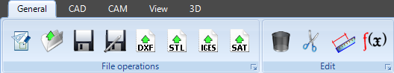
The general menu includes the standard file and basic editing commands.

Variables. Opens the variables table of the current document.
New document. Create a new project. Every unsaved change will be lost.

Distance between 2 points. . Calculates the distance between 2 selected points.
Open document. Hicam project files have extension“hpj”.
Save. The current project will be saved with
the current name. If no name was yet given, the user is prompted to enter it.
Cut object. Prompts the user to select in main editing window the objects to be deleted.

Save As… Saves the current project but
prompts the user for the project name.
Cleanup project. Deletes all objects in
current drawing database.
Import from SAT file. Import 2D geometries on current WorkPlane.
Import from DXF file. Import 2D geometries on current WorkPlane.

Import from STL file. Import 2D geometries on current WorkPlane.
Import from IGES file. Import 2D geometries on current WorkPlane.

View
The view menu control the project display options.
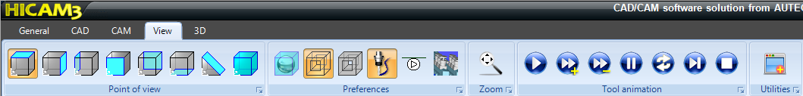
Simulation control: these commands control the simulation of current project (start, pause, stop, increase/reduce speed). Every tool movement is shown to verify program execution against possible collisions.
Viewpoint setting: these commands set the viewpoint to be orthogonal to the 6 standard WorkVolume faces, to current WorkPlane or a perspective 3D view.

Surrounding Box. This icon shows/hides the overall external volume, the surrounding box external to all entities in the drawing.

Zoom All. Regenerates the full drawing including all entities
Wireframe Mode On/Off. All solid faces are represented alternatively with their external edges or in solid colors.

Machine 3D model.
Ghost Tool On/Off. This icon shows/hides the ghost tool on geometries.
Transparency Mode On/Off. All solid faces are shown alternatively opaque or partially transparent.
Does not work when wireframe mode is on.
ToolPaths On/Off. This icon shows/hides every tool path in the project.

Additionally to the commands shown the last one (Utilities) allows control of the various frames visible in the workspace: please see chapter 5 for a complete description.

CAD
The CAD menu includes all commands required to generate drawing entities in the drawing space.
A drawing entity may be a simple graphical object as a segment or an arch, but also a complex geometry composed by an arbitrary sequence of lines and arches connected together.
The following figure represents the CAD menu as shown in Hicam3 after clicking on the CAD tab just above the ribbon.

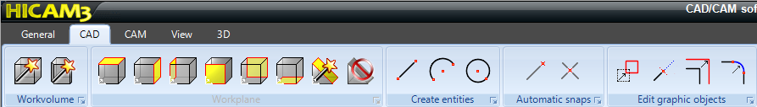
WorkVolumes: See chapter 6.3.2. WorkVolumes are very helpful when a part must be machined on its different faces. Conventionally (but it is not mandatory) the WorkVolume corresponds to the overall finished part size.

WorkPlanes: See chapter 6.3.3. WorkPlanes are the planes in the space where geometries and machining are created. Conventionally but it is not mandatory) a WorkPlane corresponds a face of the finished part.

Create Entities: See chapter 6.3.1. Graphical entities are the basic building blocks for every machining: ToolPaths are always created from geometries which are then made of single graphical entities.

Object Snap: See chapter 6.3.6. Object snap provides an extremely practical and easy way to create geometries when related to existing ones: instead of typing in cumbersome numbers, object snap provide an intuitive and quick way to point directly to main reference points of
already existing entities.

Edit Entities: See chapter 6.3.5. Entities may be copied, moved, extended trimmed by mean of the commands provided within this menu.

Create entities
Graphical entities are lines and arches. An entity must always lie on a plane, the so-called “WorkPlane”. This menu provide a collection of commands to easily create graphical entities in the currently active WorkPlane.
Multiple options are given to create arches and circles to enable the user to select the best one according to the current drawing context. In fact often it is easy to determine one of the arches properties but not all (the centre point of a circle may be given but not its radius or diameter).

The create entities menu contains 3 menus:
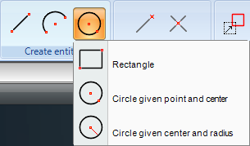
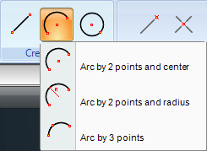
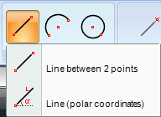

Each command is selected by clicking on the corresponding line/icon: immediately the main editing window switches to the corresponding entity creation mode and prompts the user to select the first point. The bottom row of the main editing window will look as follows:
The point coordinates may be entered numerically, by clicking with the mouse in the corresponding fields shown above, or by clicking with the mouse on a point in the editing window.
When clicking freely with the mouse on the screen the values entered depend from many factors (view mode selected, zoom factor, etc.) and therefore are quite hard to control precisely.
In case the drawing already contains some entities, a much better control may be achieved by exploiting the automatic object snap (see below).
In case of arches, the arch direction (clock-wise or counter-clock-wise) may be selected by pressing the SPACEBAR key on your keyboard before clicking on the geometry endpoint.
After selecting all points the geometry is shown immediately in GREEN color, but the command remains active assuming previous end-point as a new start-point. This enables a very quick creation of multiple entities without the need of selecting the menu items every time.
The entity creation mode may be terminated by pressing the ESC key on the keyboard or the right mouse button.
Note: when multiple entities are created within the same command session (e.g. multiple line segments are created sequentially before exiting the entity creation mode) they automatically belong to the same geometry.
When entities are instead created in separate sessions or with multiple invocations of entity creation commands (e.g. lines and arches), they will belong to separate geometries even if the endpoints correspond.
The user is therefore strongly advised to enable the display of ghost tool (see chapter 6.2) in the
View Menu because every this is the only way to verify if concatenated entities are already combined in a single geometry or if they are just separate geometries.
When multiple entities are intended to make a single tool path, they must belong to the same geometry and, in case they don’t, use the JOIN command in the CAD Menu -> Edit Entities -> Join Entities to create a single path.
The following picture represents two identical sequences of lines, but the top one is made by separate geometries while the bottom one is made by multiple entities grouped into a single geometry. The difference at the graphical level is visible only when the ghost tool is enabled but when the machining is then generated in the first case we will have a long sequence of independent machinings while in the second case the machine will route this path in a single continuous operation.

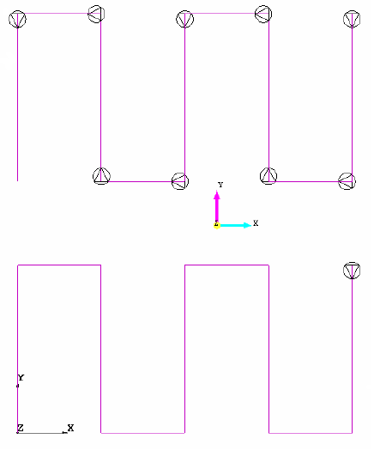
Joined entities: only one ghost tool ad one
endpoint. All entities will make a single tool path.
Separate entities: one
ghost tool for each one.
Ghost tools mark the start point of each geometry, its routing
direction as well as the
correction side which will then be applied when generating a machining.

WorkVolumes
Any Hicam project may contain one or more WorkVolumes.
Each one may be just a simple cubic object whose dimensions correspond to the overall part dimensions but also more complex WorkVolumes may be created with a much more complex shape.
A WorkVolume provide and easy and convenient way to create the WorkPlanes corresponding to the side faces of the machined parts: its vertexes may be easily selected with the object snap feature to create machining on each side face.

Cubic WorkVolumes
A cubic WorkVolume may be easily created by clicking on this icon:
After clicking the main editing window enters in the WorkVolume creation mode and the bottom
line prompts the user to enter the 3 dimensions of the volume:
The three fields shown above correspond respectively to dimensions along axis X, Y and Z.
After entering each value the cursor may be moved to the next one by pressing the TAB key.
When all data have been entered, by pressing ENTER the bar then changes as follows:
Now the user is prompted to define the insertion point of the WorkVolume, corresponding to its front bottom left corner. If the volume must be simply created in the absolute origin, just leave these field to 0. When all data are one more time confirmed by pressing ENTER the screen will look similar to the next picture.
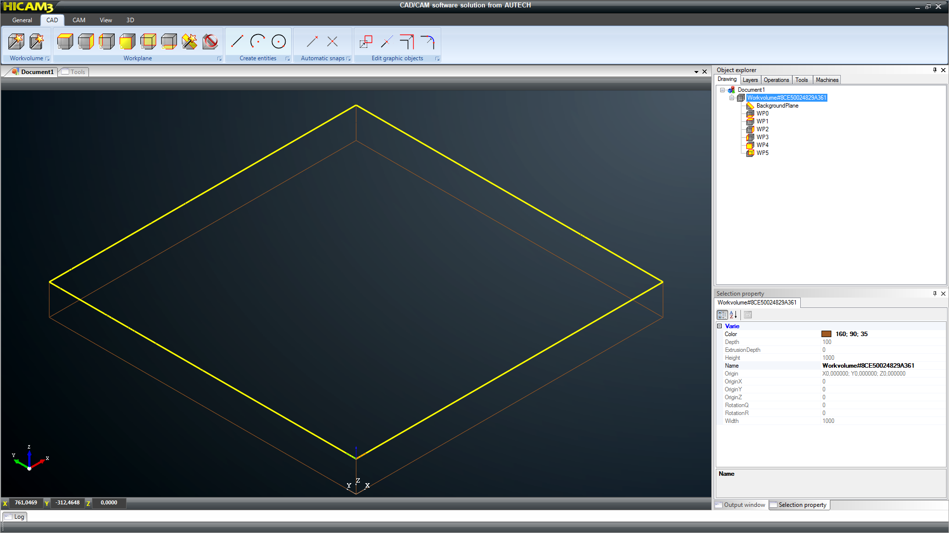
As shown in the object explorer frame on the left side of this picture, the just created WorkVolume comes pre-configured with all WorkPlanes corresponding to its 6 faces.
The “Background” WorkPlane corresponds to the actual XY plane in the “free space”.
Note: some postprocessor may require the WorkVolume to be defined even if machined parts doesn’t require any operation on its side faces. Please check with the postprocessor documentation / release notes for a description of the proper part design techniques.
The WorkVolume representation changes according to the visualization mode: in Wireframe mode only the volume edges are shown in BROWN color, in Shade mode the volume surfaces are similarly represented in a light brown shaded color.

Shaped WorkVolumes
A shaped WorkVolume is a generalization of the previous case where the volume “footprint” is a
generic closed geometry instead of a simple rectangle.
To generate a shaped WorkVolume the first step consists always in the creation of a free-form
closed geometry (in the global space, at z=0); it may also be imported as a 2D dxf file.
Then click on the icon corresponding to the shaped WorkVolume generation:
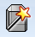
The geometry may be made by an arbitrary amount of entities and the only constraints are:
- they must be all perfectly joined together (it is strongly suggested to check the proper joining by mean of checking how many ghost tools are shown… only one should be visible for the geometry!)
- the geometry must be closed, in other words the endpoint of its last entity must correspond to the start point of the first one.
The following picture shows a shaped WorkVolume obtained by a base geometry which intersects itself multiple times: if all entities are properly joined together and the geometry itself is closed, the volume is correctly generated anyway.

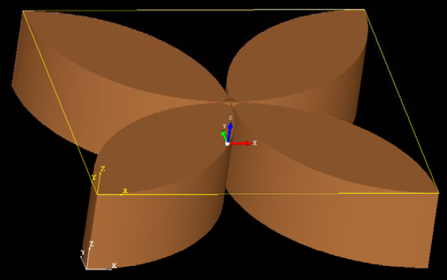

In case of a shaped WorkVolume, the side faces correspond anyway to the “containing” cubic WorkVolume.

WorkPlanes
When a new project is started in Hicam, the drawing space is completely empty and the default coordinate system is the “global” one.
Hicam supports creating geometries in the 3D space but such entities cannot be used to create tool paths because there’s no information about the tool orientation and how the tool radius correction is supposed to operate.
In other words, when a geometry (basically a line in the space) is converted into a tool path, the system must also determine the tool orientation and, consequently, the tool displacement for the radial correction.
To achieve this goal, the best and most consistent technique used is to create every geometry not actually in the open space but on a PLANE defined in the space. The plane has its own origin, to which all coordinates are referred, and its “normal” (=perpendicular) direction will define the tool orientation. The radius correction will then operate on this plane again in a direction perpendicular to the set geometry.
As an example, the picture in the previous page shows a shaped WorkVolume where the top face is selected as the current WorkPlane (in YELLOW, the absolute origin is instead WHITE).
The Z axis of the selected WorkPlane determines the direction from which the tool will approach
the geometry: the golden rule is that the Z axis must always point OUTSIDE the WorkVolume because the tool will come from that side.
An arbitrary amount of WorkPlanes may be defined in each project, but whenever a WorkVolume is created, the basic 6 planes corresponding to its faces are created as well.
Note: It has to be reminded that the geometries and the WorkPlanes programmable in Hicam may not be compatible with the machine capabilities! The user is responsible at any time to make sure which are the actual machine capabilities and to generate geometries compatible with them!
The WorkPlane selection toolbar provides an easy and immediate way to select each of the standard 6 planes, but an additional command is provided to create an inclined WorkPlane anywhere in the space.
Top Face: After clicking on this icon the current WorkPlane will be the top face of programmed WorkVolume. This will be the
most frequent selection because most of the machinings are programmed on this side.
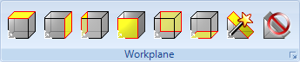
Right Face: After clicking on this icon the current Work-Plane will be the right face.

Left Face: Click on this icon to select the left face of WorkVolume.

Front Face: Click on this icon to select the front face of WorkVolume.
Rear Face: Click on this icon to select the rear face of WorkVolume.
Deactivate WorkPlane: Whichever WorkPlane is active, it will be deactivated but it will remain stored in the object explorer for further processing.
New WorkPlane: Click on this icon to create and activate a generically inclined WorkPlane in the volume. A dialog box will open up: please see chapter 6.3.3.1 for a detailed description.
Bottom Face: Click on this icon to select the bottom face of WorkVolume as the current WorkPlane. Warning: most machines are not capable to perform any operation on this side.

Generic WorkPlanes
Whenever the WorkPlane creation icon is clicked the following dialog box will show up:
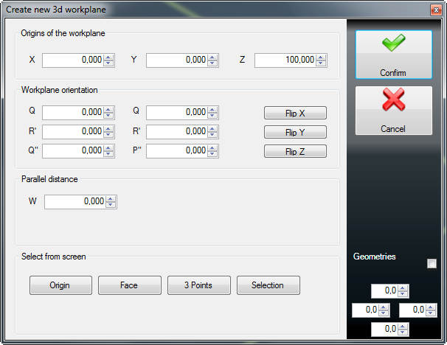
The controls available in this dialog box allow and easy selection of the inclined WorkPlane and of its origin and axis orientation.
It has to be remembered that a plane is a 2D structure in the 3D space and from a purely geometrical point of view every point of the plane can be its origin, additionally the X and Y axis which define the WorkPlane local coordinate system may be rotated at any angle.
Finally a plane has two sides, this means that the tool may approach the plane from both sides: the Z axis will define which is the “external” side (the one the tool is coming from) and the “internal” one.

Origin of WorkPlane: these values are the coordinates of the WorkPlane origin respect to the global origin of the 3D space. These values may be just typed in the corresponding fields, may be adjusted by clicking on the up/down arrows provided for each value but the point may be get directly from the existing project by mean of the automatic object snap feature. These X,Y and Z
values will always show the current origin of the WorkPlane and the main editing window will show a preview of the plane.

Orientation: These 2 parameters control the rotation of the local XYZ axis respect to the “global” ones.
Q defines the rotation of the local X axis respect to the global one according to the standard goniometrical direction (positive counterclockwise). Examples:
- Q=0 means the local X axis is parallel to the global one (top or front face).
- Q=90 means that the local plane X axis points backward, as it happens for the right face.
- Q=180 means that the local X axis is parallel but in opposition with the global X axis (rear face)
- Q=270 means that the local X axis points frontward, as it happens for the left face.
R defines the angle of the Z axis respect to the vertical direction. Example
- R=0 means the local Z axis is parallel to the global one (horizontal WorkPlane, vertical Z).
- R=90 means that the local Z axis is horizontal as it happens for all side faces.

The following picture shows an example of a generically inclined WorkPlane: whenever one of the values in the dialog box is changed, the main graphic frame will show a preview of the selected plane according to the current settings.

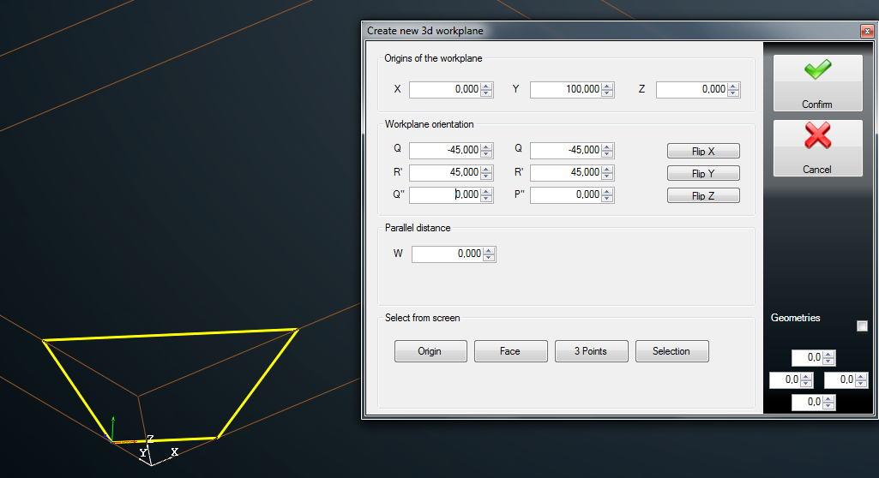

This picture shows that the local X axis is rotated -45° resp. the global one (negative values mean CW rotation) and also the local Z axis is rotated 45° resp. to the global one.
Warning: not every machine may be able to generate properly such tool orientation: it may be possible or not according to machine structure and tooling; such tool orientation may be achieved by mean of angular aggregates fit on machining head or by proper head rotation axis fit on machine. Please refer to machine and postprocessor documentation for further reference about machinings allowed in a specific case.
The user is suggested to practice for a while with this command in order to properly understand the meaning of these fields by changing one at a time and checking the actual plane in the graphical frame.
Even if every inclined plane may be programmed by typing in these 5 fields the corresponding values, in many cases it is advisable to exploit the entities already in the drawing to build more effectively and quickly the actual WorkPlane. For this purpose some additional controls are provided which will be described in the following paragraphs.
Flip Axis: select the best axis rotation for the inclined plane.
According to the specific plane selected, the most convenient axis rotation may be different from
the standard one. According to the chosen axis system, the value then printed in the actual CNC program instructions may be absolutely indecipherable or relatively easy to understand: for
obvious reasons it is highly recommended to choose an axis system which generates simpler coordinates which will make further verification and debugging a lot easier.
Mostly in case of imported solid models, the local origin of individual faces may be placed in very unusual places, at least from this point of view. It is therefore particularly useful to choose an origin and an axis system on the local WorkPlane keeping program readability in mind.
In the following picture is shown an example of the behavior of this command in the case of the inclined plane shown above.

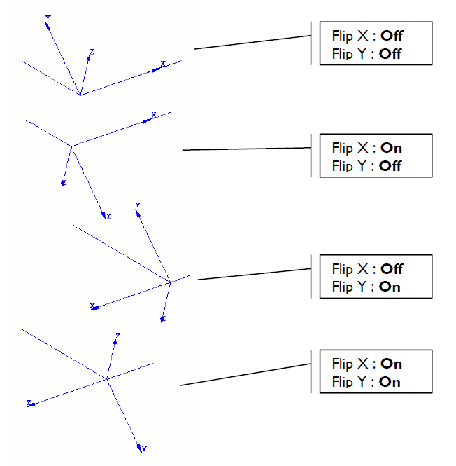

As shown in this example, one single flip operation will invert X or Y axis direction but also the Z
(causing the tool to approach the plane from the opposite side): this may generate errors in the program execution but also possible collisions between the tool/head and machine components.
The user should therefore warned always to check the direction of the Z axis: the tool will always approach the geometry from its positive side; the Z axis must always point outside the material.

Parallel Distance: Sometime may be required to generate a WorkPlane parallel to a given one, at a certain distance. By typing any non-null value in this field the local WorkPlane will be shifted by this amount along the Z axis.
Clone Objects: When creating a WorkPlane having selected one which already contains objects (geometries), by checking this box all entities lying on the original WorkPlane will be copied on the new one. This may be useful in case of pocket milling, etc.

“Origin” Button: This button allows to select another point of the local WorkPlane as its origin. Similarly to the flip buttons, a clever selection of the WorkPlane origin may result in a much more readable program, which makes then easier verification and changes “on the fly” to the CNC program.
When this button is clicked the dialog box temporarily disappears to leave the user free access to the main editing frame. The new origin may be chosen by clicking directly on the screen, but normally the preferred way is by exploiting the automatic object snap feature.
Try to enter this mode and move the mouse pointer on the screen, assuming some entities have
already been drawn… whenever the mouse reaches a notable point a small circle appear showing that the software identified that particular point as the potential new origin. To confirm the selection just click close to that circle and its coordinates will be automatically transferred to the XYZ values in the WorkPlane selection dialog box.
The following picture shows what happens in a typical case:

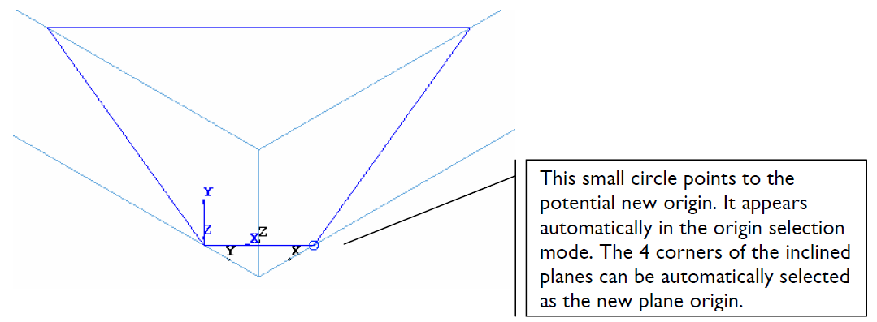

“Face” Button: This button is useful when the local WorkPlane must be selected matching a face of a 3D model imported from other CAD applications. Similarly to the previous button, when
clicked the dialog box disappears and the main editing window is shown prompting the user to select any planar face of the 3D model. The following picture shows an example:

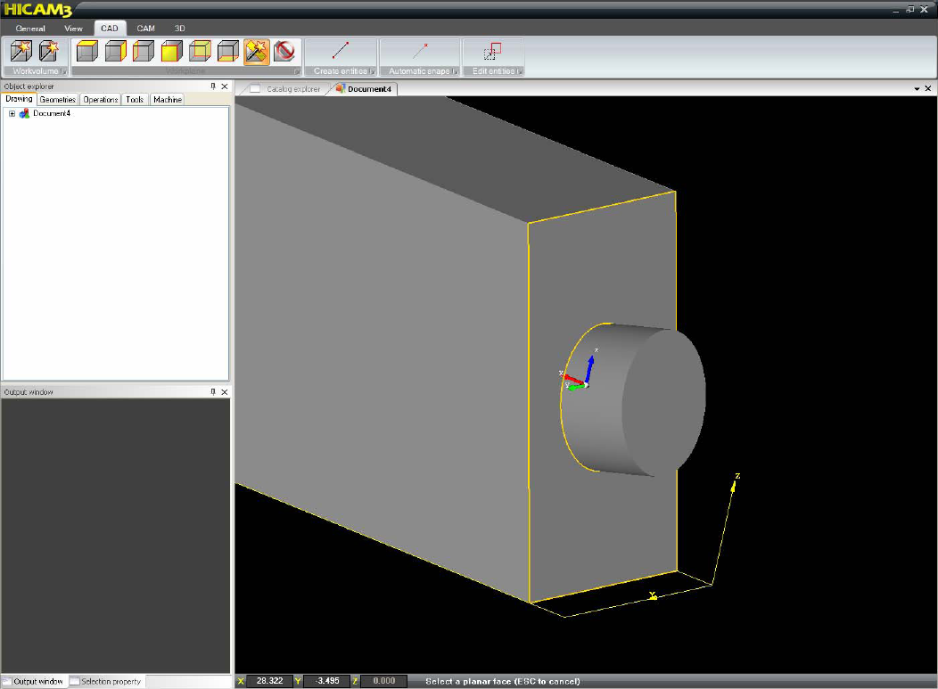

The solid model here shown was generated by a 3rd party CAD application and then imported into Hicam as an ACIS – SAT File (the import module is an optional add-in of the basic package); to generate the machining which produces the round mortise the bottom face must be chosen as the current WorkPlane.

When the “Face” button is pressed the dialog hides and (see above) whenever the mouse pointer moves above a planar face of the 3D model its boundaries are highlighted… just click with the mouse on the face and it will be activated as the current WorkPlane.
The origin will be automatically selected as the original face origin (chosen by the 3D CAD Modeler which created the original face) and most likely will not be the one best suited to CNC program generation, but then the “Origin” button allows to easily select another point.

“3 Points” Button: A WorkPlane may be selected also by choosing 3 independent points in the
space, normally reference points of existing geometries. After clicking on this button, similarly to previous cases, the dialog box hides itself and the user is prompted to select in the main editing frame the new plane origin point. A small circle will identify endpoints of existing geometries as soon as the mouse get close to them. When the desired origin has been chosen, the user is prompted to select in the same way a point which will define the local X axis and then another last point for the local Y axis.
These points may be chosen from geometries lying on any existing plane. As soon as the 3 points have been properly entered the new WorkPlane is immediately shown.
“Selection” Button: To recover quickly the plane an existing geometry was created on, just click on this button and then on the desired geometry. Then its local WorkPlane will appear immediately.
Finally, to complete the command and activate the selected WorkPlane, click on “Confirm”. Alternatively “Cancel” revert back to the previously active plane, if any.

Edit entities
This menu provides a series of commands intended to manipulate the existing entities.

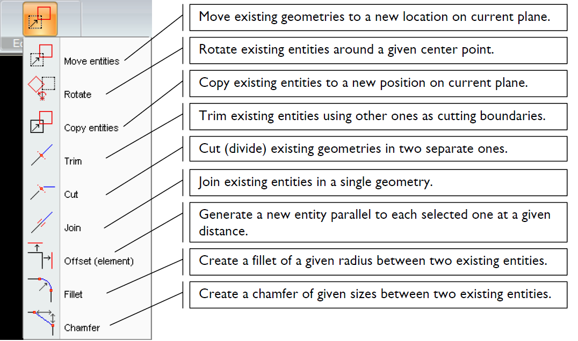

All these command require the user to select the entities to be edited and this process happens always by clicking in the main editing frame with the mouse. The selected entity(ies) are shown in blue. Because each command operates on many entities at a time, the editor will stay in selection mode until all entities have been selected: the user may exit this mode by pressing ESC on the keyboard or by clicking on the right mouse button. Press ESC (or right click) multiple times to abort the command.
To select multiple entities simply left-click with the mouse on them (their color will turn to blue to confirm the selection). Alternatively a selection window may be drawn by left-clicking with the mouse on one corner and then dragging to the other corner: all entities fully included within (not crossing) the window boundaries will be added to the selected ones.
Each command requires a different input due to its operation:
Move: After all geometries have been selected, the user is prompted to select the reference base point and finally the reference destination point. These 2 points define a vector and all geometries will be moved exactly by the vector length in the vector direction.
Rotate: After all geometries have been selected, the user is prompted to select the rotation center point and to type in the rotation angle. All selected geometries will be then displaced to the new position.
Copy: After all geometries have been selected, the user is prompted to select the reference base point and finally the reference destination point. These 2 points define a vector (length and direction). A copy of all selected geometries will be created in the new location defined by the original one shifted by the vector length and direction.

Trim: In trim mode, as soon as the mouse moves on a geometry on the main editing frame, the segment defined by the two surrounding intersections will be highlighted (white). If the left mouse button is clicked on it, this entity segment will be deleted.

Cut: the selected geometry will be divided in two separate ones at the chosen boundary point.
Join: all selected geometries will be grouped into a single geometry, at least as long as they are
concatenated. In other words only geometries having one endpoint in common are joined. The others are left unchanged. The joint operation can be easily checked by enabling the ghost tool (see chapter 6.4)

Offset (elements): After the offset distance has been entered, as soon as an entity is chosen the user is prompted to click with the mouse on the side where the new entity should be created. This process may continue indefinitely until the right mouse button or ESC key is pressed.

Fillet: After entering the required fillet radius, the user is prompted to click on a vertex between two geometries. The vertex will be replaced by the fillet and the original entities will be trimmed accordingly to create a single continuous geometry.

Chamfer: After entering the first end second chamfer lengths, the user is prompted to click on a vertex between two lines. The vertex will be replaced by the chamfer and the original entities will
be trimmed accordingly to create a single continuous geometry.

Automatic object snap
The automatic object snap allows a precise and quick selection of an existing graphical entity reference point without any numerical data typing.
The object snap may be activated in every case the user is prompted to select a point in the various commands provided by the menus. The Object snap mode is activated by selecting any of the menu items listed below or alternatively by pressing on the keyboard the corresponding
function key (see below between parenthesis).
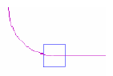
When the object snap mode is enabled, a small square will surround the point found according to current mouse position. If left mouse button is clicked now, the point coordinates returned to the active command will correspond to the ones of the marked point instead of the real pointer position.
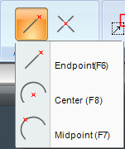
Marks the midpoint of the geometry below the mouse.
Marks the center of the arch/circle below the mouse.
Marks the endpoint of the entity pointed by the mouse, closer to its current position.

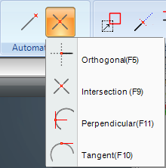
When drawing lines, will terminate a line segment tangent to the arch/circle below the mouse.
When drawing lines, will terminate a line segment perpendicular to the one below the mouse.
Marks the intersection point of two geometries, closer to its
current position.
When drawing lines, will
Marks horizontal and vertical guidelines

If no solution is found for the current mouse position, no square mark is created and then a leftclick will return the actual mouse pointer position.
The automatic snap mode can be exited by right clicking with the mouse or by pressing the ESC key on the keyboard.

CAM
The CAM module generates tool paths starting from existing geometries. The available commands are shown in the next picture and they have been divided into three separate groups:
- The first one is intended to edit current geometries to prepare them to properly generate tool paths.
- The second group is provided to generate the actual machinings.
- The third group is dedicated to the CNC program creation.

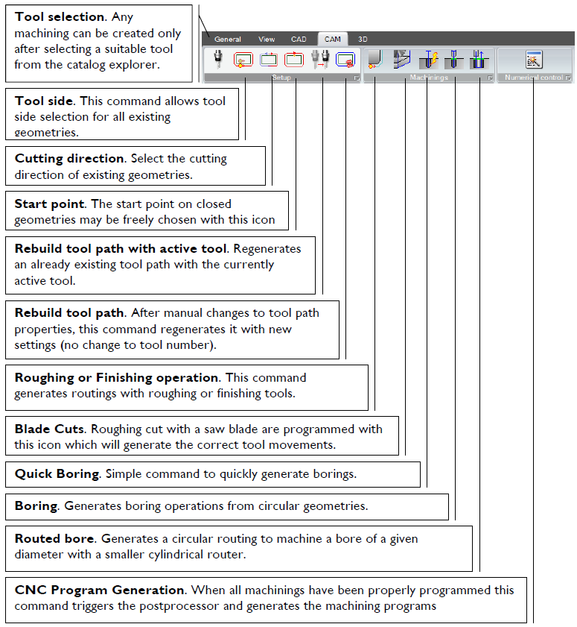

Tool selection
(See also chapter 5.8 about the Tools)
By clicking on this icon the catalog explorer is shown allowing the user to edit the tool list and to select the “active” tool.
No machining may be generated if there’s no active tool, only one tool may be active at a time.
The only way to activate a tool is to open the catalog explorer and to double-click on its icon (or alternatively to click on the “tool activation” icon after selecting it… just a slightly different way to
do the same operation).
When a tool is activated, the main editing window is shown again and the tool is represented orthogonal to the currently selected WorkPlane.
The next picture shows how will look the screen after selecting a shaped router to route a part edge:

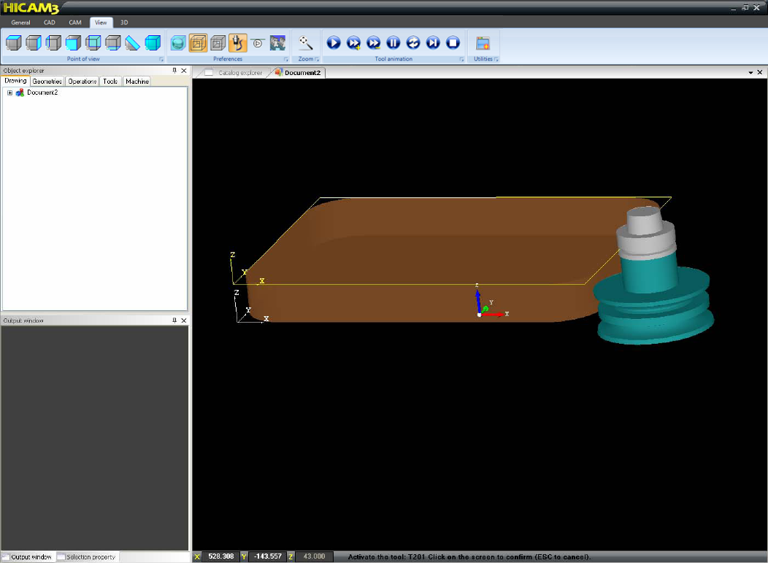

The tool moves freely in the space with the mouse and status bar at the frame bottom provides a short information about what to do: just left-click to confirm the tool activation or right-click to cancel the operation.
After a tool has been selected all operations generated will use it until another one is selected.
If a machining were generated with the wrong tool, it is possible to rebuild the same operation by assigning another tool (see below).

Tool radius correction
The tool radius correction is controlled by the ghost tool (see also chapter 6.2): the tool center point will always follow the position of the ghost tool; the following picture represents the three possible options:

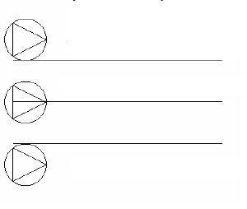
Right Hand Correction. The tool will always be positioned on the right side of programmed geometry.
Center Point. The tool tip will always be centered on the programmed geometry.
Left Hand Correction. The tool will always be positioned on the left side of programmed geometry.
To select desired ghost tool side, simply click on the icon 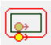 and then click on the various geometries shown in the main editing frame (make sure to enable ghost tool visualization before starting this operation): every time a geometry is clicked on, its tool side will toggle between the three options listed above… just click until the required one is shown and then pass to the next geometry to edit. At the end, as usual, press the ESC key on keyboard or right click with the mouse.
The ghost tool is an “abstract” information which simply defines on which side of the geometry the tool will be placed: the actual tip coordinates will be determined according to the tool correction radius defined in the tool catalog.
When generating any routing operation (see below) there will be three possible ways to control the tool radius correction: it is user responsibility to choose the best one according to the actual tool management and the numerical control of the machine. The three possibilities are listed here:
- Software calculation: tool correction is calculated by Hicam. The CNC part program will show the actual tool center point coordinates determined by Hicam according to the tool correction radius stored in tool properties. This solution is useful in case of very old numerical controllers which could not yet support radius correction but also in case the user prefer to manage the machine tooling in Hicam.
- NC G41/G42. The CNC program will show the actual part geometry coordinate and tool radius correction is calculated by the machine’s numerical controller. The postprocessor will generate the instructions required to invoke the proper corrector number and correction side for the actual NC installed in the machine (e.g. G41 for left hand correction or G42 for right hand). It is user responsibility to properly manage the tool corrector table in the NC itself but also the corrector number to be invoked for each tool configured in Hicam catalog editor.
- NC G41/G42 on tool center. This case is an hybrid situation combining both previous options: the part program shows tool center point coordinates as in the first case but still the instruction to activate corrector and correction side will be included as in the second case. This case is (rarely) preferred when the corrector table in machine’s NC stores not the actual tool radius but the “error” measured between the expected (nominal) tool radius and the real (measured) one. In other words, Hicam stores the “nominal” tool data and generates programs accordingly. The machine operator has the possibility of measuring the tools, and will store in NC tool table the “error” measured (e.g. after resharpening):
the part will be then machined correctly anyway and there’s no need to tamper with Hicam configuration (which may be installed in another location respect to machine) and regenerate part programs after each tool resharpening.

Geometries and ToolPaths
Any geometry, whether “open” or “closed”, has a startpoint and an endpoint. By mean of the ghost tool the user shall always check if a contour which look continuous on the screen is actually made by a single or multiple geometries. This has a fundamental importance because a routing operation will always be determined from the geometry chosen (see below)… if a contour is made by many geometries which only appear joined, the result will be a series of separate machining which may result in an unacceptable quality.
The ghost tool is the fundamental aid to avoid such a situation, because any instance of the ghost tool in the drawing will mark the startpoint of a new geometry: any undesired/wrong one can be pinpointed and immediately fixed.
Also the object explorer frame lists all existing geometry on each WorkPlane and thus allows to pinpoint and fix wrong/spurious geometries in the drawing, but definitely the ghost tool is by far the quickest and most immediate way to perform this simple verification.
There are 2 types of geometries:
- Open: startpoint and endpoint are two different point. For an open geometry it is possible to choose the “direction”, in other words which endpoint is actually the startpoint.
- Closed: startpoint and endpoint are always coincident and may be chosen in any point of the geometry (e.g. a circle, rectangle or any loop). Additionally also the direction may be chosen Clockwise (CW) or Counterclockwise (CCW).
The ghost tool again comes handy to control startpoint and cutting direction for each geometry: it is always shown in the startpoint and the “triangle” in it always point to the cutting direction.
To change the cutting direction (valid for both open and closed geometries), click on the icon:
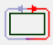
Then, in the main editing frame click on any of the existing geometries and its cutting direction will be automatically reversed: for open ones, startpoint and endpoint are reversed, for closed ones instead simply the ghost tool will point in the opposite direction. At the end, as usual, press the ESC key on keyboard or right click with the mouse.
Finally, to change the startpoint on closed geometries, click on the icon:
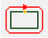
Now, by mean of the object snap feature, it is possible to precisely position the startpoint/ endpoint on any reference point of entities belonging to closed geometries. To exit this editing mode, when finished, as usual, press the ESC key on keyboard or right click with the mouse.

Routing operations
Roughing or Finishing operations are always generated by clicking on icon: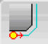. The user is then prompted to select (by left-clicking with the mouse) the geometries on which the machining has to be built; as usual, this operation is terminated by right-click or by pressing ESC on keyboard and finally the following dialog box appears prompting for the various machining parameters.

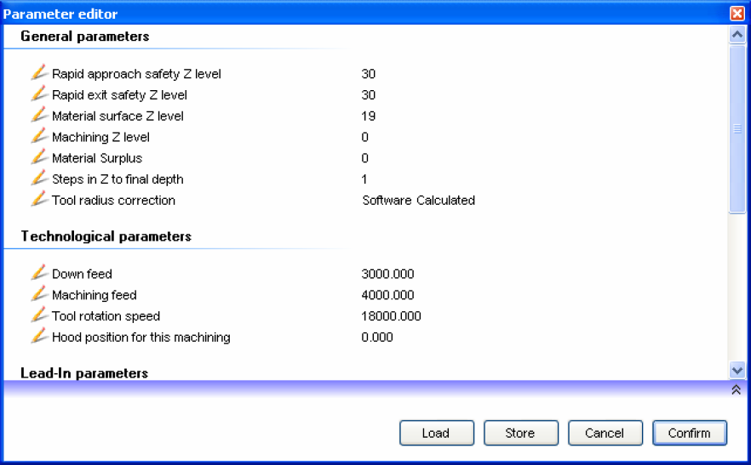

The parameters are divided into groups and most of them are common also to the other types of machining presented in the following chapters.
General Parameters:

- Rapid approach safety Z level. Defines the Z level (above current WorkPlane) above which there’s absolutely no risk of collision with parts or fixtures, where every movement may freely happen at G0 (rapid) speed. Before the machining, the tool will be “lowered” at rapid speed until its bottom point (defined in tool catalog by the overall dimension in Z) arrives at this level. From this point on the tool lowering will happen at the programmed speed (slower).
- Rapid exit safety Z level. Defines the Z level at which the tool bottom point (defined in tool catalog by the overall dimension in Z) will be raised before starting any movement toward the next startpoint. Any machine device, clamp or fixture, material part must be below this level.
- Material surface Z level. When machining on an inclined plane positioned inside the working volume of a solid object, according to part shape and plane orientation, the amount of material above WorkPlane may be variable from point to point… this parameter is intended to configure a value which is added to the safety Z level above to ensure tool lowering and detaching happen well outside the material… in other words, if the machining happens on a inclined plane whose depth respect to part material varies (e.g. from a min. depth of 15mm to a max. depth of 37mm) enter here a value corresponding roughly to the max. depth.
- Machining Z level. The Z level respect to current WorkPlane at which the tool tip will be lowered. A null value means the tool tip will move on the WorkPlane itself. A positive value means the tool tip will be above it, a negative value means it will be lowered below.
- Material Surplus. This parameter applies only if ghost tool is not on geometry center. The amount programmed here will be added to tool radius to leave the set amount of material respect to programmed geometry. This parameter comes handy when the same geometry must be routed multiple times, at first with some roughing tool and then with a finishing tool. Normally the finishing tool requires some surplus material to be left to achieve the expected quality and this setting is intended for this purpose. In case of software calculated tool radius correction or NC G41/G42 on tool center point, this parameter is added to tool radius directly by Hicam. Differently, if NC G41/G42 is chosen, please refer to postprocessor documentation for a description of the behavior of this parameter.
- Steps in Z to final depth. If the final cutting depth is higher than the amount of material the tool is supposed to cut each pass, this parameter allows to divide the cut in multiple passes in order not to overload the tool cutter. Just write here in how many passes this machining should be done and Hicam will automatically generate the set amount of machinings at the various cutting depths, evenly spaced.
- Tool Radius Correction. See chapter 6.4.2 above.

Technological Parameters:

- Down Feed. Feed rate programmed during the tool lowering from safety Z level to cutting depth. The value, expressed in mm/min, is pre-set to the value configured in the corresponding property of active tool.
- Machining Feed. Feed rate programmed during the machining. The value, expressed in mm/min, is pre-set to the value configured in the corresponding property of active tool.
- Tool Rotation Speed. Tool spin rate during the machining. The value, expressed in rpm (revolutions per minute), is pre-set to the value configured in the corresponding property of active tool.
- Hood Position. This parameter applies only to machines/routing units fitted with a programmable dust extraction hood and is intended to be programmed to the desired value for the hood for the best dust suction without collisions between hood assembly and part or fixtures. Please refer to the postprocessor documentation for a description about this parameter effect on your machine.

Lead-In and Lead-Out Parameters

Often, due to tool shape, quality isues or simply for the correct machining, the tool cannot be just lowered at the geometry startpoint and then detached at the geometry endpoint. Many CNC machining centers will leave a mark on the processed material or, especially in case of large shaped routers common in woodworking (e.g. Thoroidal Routers, Lollipops, Doors & Windows shaped routers, etc.), such movements may actually damage the part and/or the tool itself.
To achieve the correct operation / expected quality, some additional entities are added to the original geometry to extend the tool trajectory in a way to enter and exit “gracefully” the programmed path. These additional elements are called “Lead-In” and “Lead-Out” respectively.
These parameter allow a full control of these entities to achieve the best result.
The parameters are differentiated between lead-in and –out to achieve the maximum flexibility yet guaranteeing the best quality and safety of operations.

- Type: there are 3 possible options for the lead-in/out paths: None, Line, Arch + Line.
- None: in the first case, as you may have already supposed, no lead-in/out path will be created at all. The tool will be lowered at geometry startpoint and detached at endpoints.
- Linear: The lead-in path is made with a simple straight line. If the next parameter (Angle) is set to a positive value, this segment will be created at the set angle with first/last geometry entity. Normally, if just a linear lead-in/out is chosen, Angle is set to 0 to ensure tangency of entities. This setting is common whenever the startpoint/endpoint is on a vertex of the part, whichever tool radius correction option was selected.
- Arch + Line: similar to previous case, but a fillet arch is created between the lead-in line and the first geometry entity. In this case an angle value between 0 and 90° is normally configured to provide some distance between tool lowering/rising point and programmed geometry. The arch orientation is automatically determined by the correction side. This mode shall not be chosen in case no tool radius correction was programmed.
- Angle: Angle between the first/last geometry entity and the lead-in/out direction. A zero value means the lead-in/out must be perfectly in line with initial/final geometry directions. Allowed values are between 0° and 90°. The angle side will be determined automatically
according to the correction side defined by the ghost tool.
- Line Tool Radius Multiplier. This parameter controls the lead-in/out line length: it is determined by multiplying this parameter by the tool external radius (warning: not the correction radius, often smaller than the physical one); larger tools will generate longer segments. This parameter is expressed in decimal values and common values may be between 0.5 and 10 according to tool size and shape.
- Arch Radius Tool Radius Multiplier. This parameter controls the lead-in/out arch radius: it is determined by multiplying this parameter by the tool external radius (warning: not the correction radius, often smaller than the physical one); larger tools will generate bigger arches. This parameter is expressed in decimal values and common values may be between 0.5 and 5 according to tool size and shape.

Buttons at the dialog bottom line:

To keep memory of the settings chosen for a specific machining, the value set in the above listed parameters may be saved in a “technology” file to be easily retrieved in a second time. Therefore a “Save” and “Load” buttons have been provided to save on disk the current settings and to load the values from an already existing file.

- Load. Loads all values from a file stored on disk. Existing values will be discarded and replaced with ones read from file.
- Store. Stores all current values on a file on disk.
- Cancel. Closes this dialog and no machining will be created.
- Confirm. Confirms all settings and create machining accordingly.

After confirming the operation, it will be given automatically the color assigned to currently active
tool and the tool center point trajectory, including eventual lead-in and lead-out, will be represented in the main editing window. In the View Menu it is possible to start the simulation and it is therefore possible to check the actual tool operation on workpiece monitoring its movements from the lowering at cutting depth until the rapid detach to the safety Z level.

Blade cuts
A blade cut operation is programmed by clicking on icon 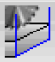 and is different from any other routing operation because of the specific peculiarities of saw blade tools:
- The tool axis is normally horizontal even if cutting geometry is programmed on a horizontal plane (top or bottom part face).
- The saw blade should be moved above workpiece at safety level, considering its outer diameter, and then must be lowered only after it has been rotated to proper cutting direction and additionally also blade kerf has been properly corrected.
- The blade cut geometry must be just a straight line. No changes in direction are allowed.
- The lead-in and out path cannot include any “arch” but instead should be made by two linear segments, an extension of the cutting line to make sure the blade lowers/rises at a safety distance from workpiece, and a vertical segment (angle =90°) to safety Z level for both lead-in and -out.
These peculiarities are considered in this command which automatically generates the correct tool movements whichever WorkPlane is selected.
The ghost tool must be set on left/right side to define on which side the spindle/aggregate gearbox shall be placed.
The Z value is now determined along blade radius instead of tool axis.
The following picture represents a typical blade cut operation: in this case the machining was programmed on the bottom edge of left face and the cutting depth set to -5mm just to ensure the blade teeth exits on bottom side to achieve a decent cutting quality.

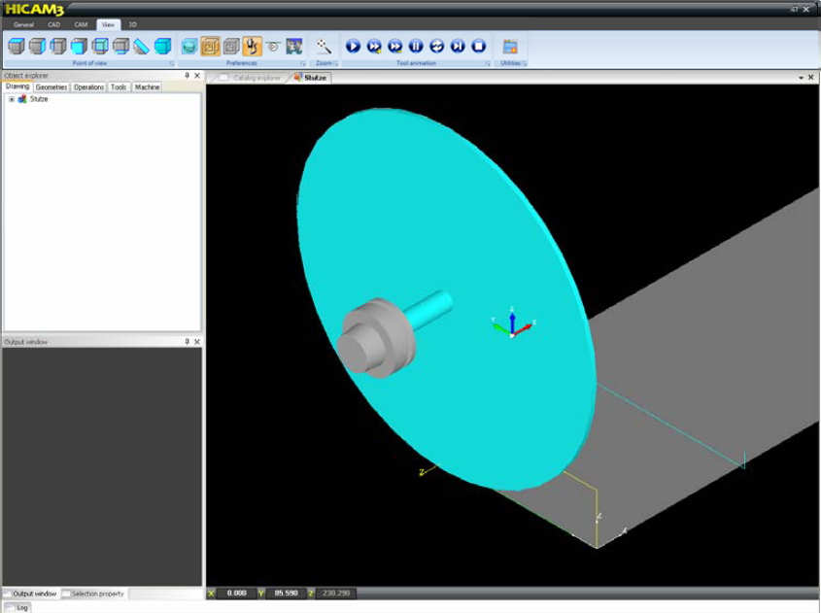

To generate a blade cut the procedure closely resembles the generation of a standard routing:
after selecting the proper icon, the user is prompted to select the geometries on which the blade
cut must be done, and then press ESC or right-click with the mouse.
As usual, the following dialog box appears prompting for the machining parameters:

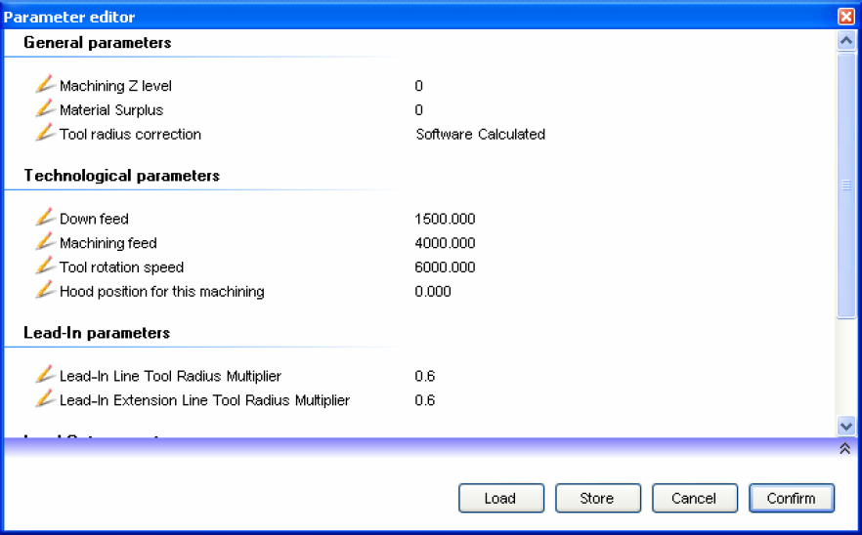
The parameters shown here have the same meaning previously seen for roughing or finishing operations. Only a few differences should be discussed here:
The material surplus now refer to the position of the blade kerf respect to cutting geometry: a zero value means that the blade will be positioned completely above the WorkPlane. See as a good reference the next picture which represent just this case:

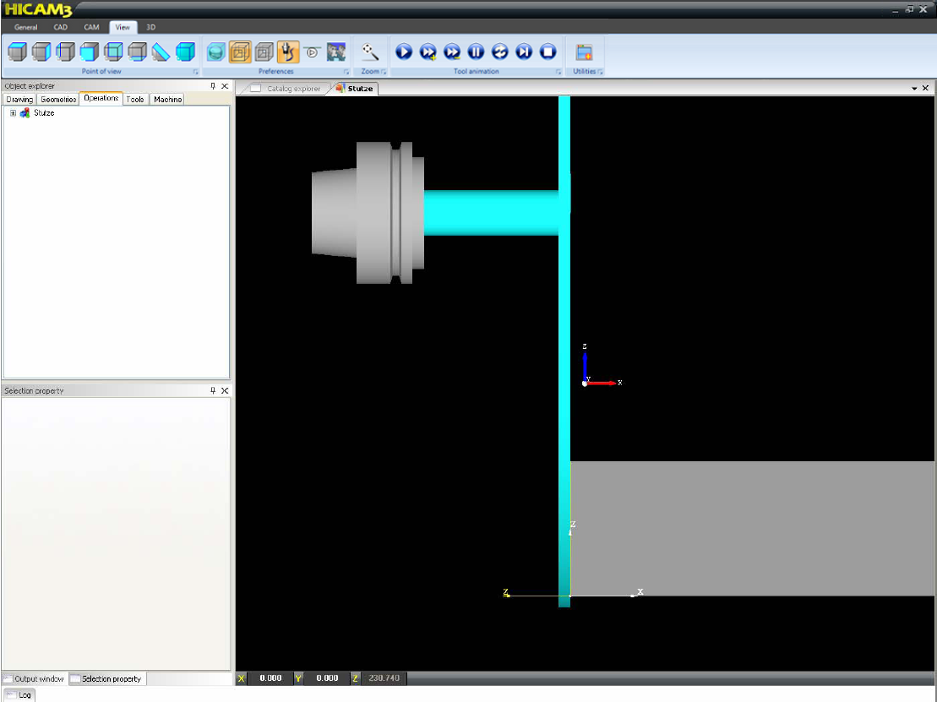

A negative surplus material would mean the tool would be lowered in the negative region of the Z axis (in other words the workpiece would result in a smaller size than programmed), while a positive surplus (as expected) would leave the corresponding amount of material (in the picture above the saw blade would be accordingly displaced on the left, in the positive direction of the local Z axis in yellow).
No “arch” or “angle” parameter is present for lead-in/out paths but we have two linear parameters, to properly control the geometry extension to ensure proper entering and exiting from workpiece.
Please refer to your postprocessor documentation about any information on how to control blade tools for your specific machine/NC.

Boring operations
There are three different commands dealing with boring operations, each performing a different task: 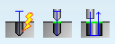.
The first icon refers to “Quick Boring Operations”, the second to the “Standard Boring Operations” and the third to the “Routed Boring Operations”.

Quick boring operations
A quick boring, as any other operation, requires a tool to be already active. In this case the active tool must be a router or a boring bit (flat or lance type).
After clicking on the corresponding icon, this dialog is immediately shown:

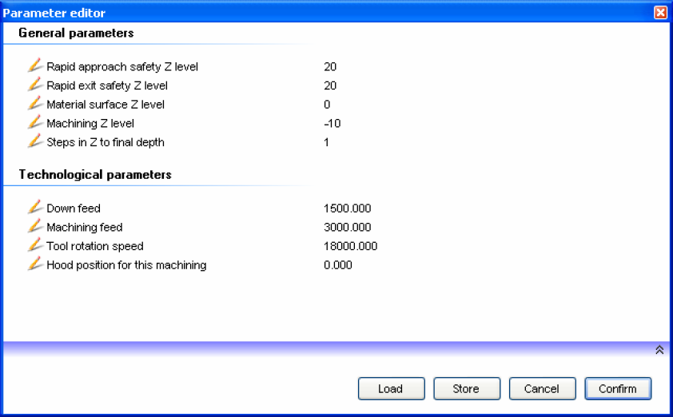

The parameter to be entered are just a few and have already been commented. Just type in the right data and click on “Confirm”. The dialog disappears and the user is now prompted to select on screen on current WorkPlane the point(s) where the operation must be generated.
At the end, terminate as usual with ESC or right-click and the corresponding operations will be shown.

Standard boring operations

A standard boring operation is very similar to the previous one but requires the bore positions to be already defined by circular geometries (simple circles centered on bore position, their diameter are totally irrelevant).
The dialog box shown after selecting all circles is exactly the one shown above and immediately
after clicking on “Confirm” the machinings are created.

Routed boring operations
A routed bore is actually a routing operation, intended for bores of larger diameter than the active tool’s one: the parameters are the same shown previously in chapter 6.4.4. The main difference in this case being that selected geometries must be simple circles (position of ghost tool is not important, instead its orientation determines the routing direction of bores).
Lead-in and out may be programmed as usual as well as the steps in Z and all other routing parameters.
The final result will look similarly to the next picture which actually shows a series of routed bores on a part for conservatories:

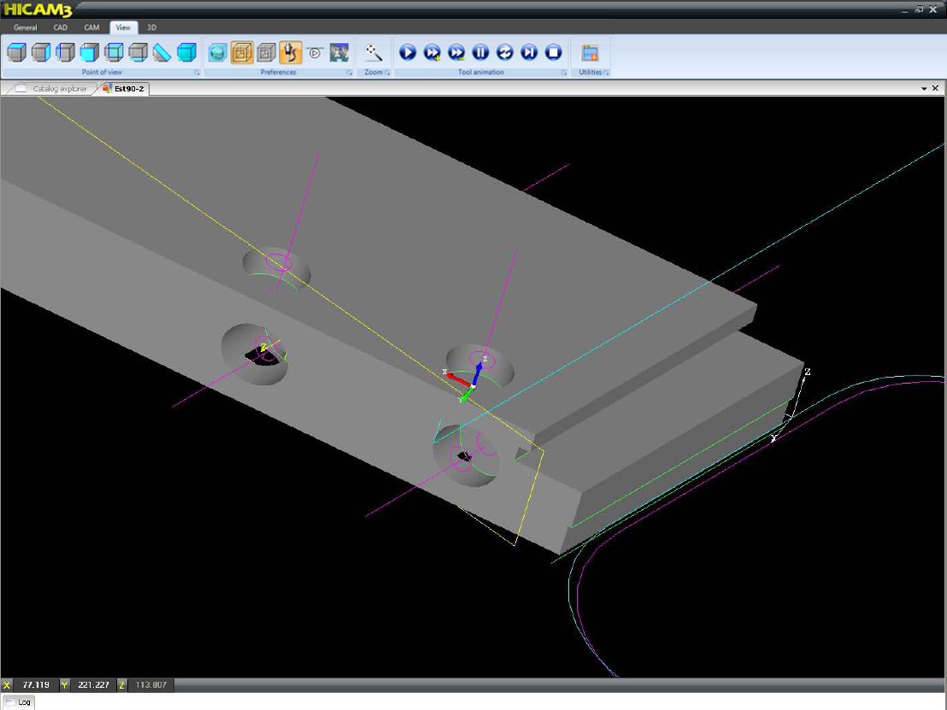

NC program generation
The NC code generator, also know as “Postprocessor”, is a peculiar component of each installation and is in charge of generating the NC part program in the specific format for the actual machining center / numerical controller.
When this icon is clicked on, a dialog shows up prompting for the destination file, and then each specific implementation will prompt the user for some machine-related parameters: please refer to the postprocessor documentation for a complete description of the postprocessor capabilities, parameters and peculiarities.

APPENDIX - ALMACH

When Hicam is configured for Almach CNC machines, it opens showing the General menu and the profile catalog (a new dedicated tab that you can find beside the Document and the Tools tabs):
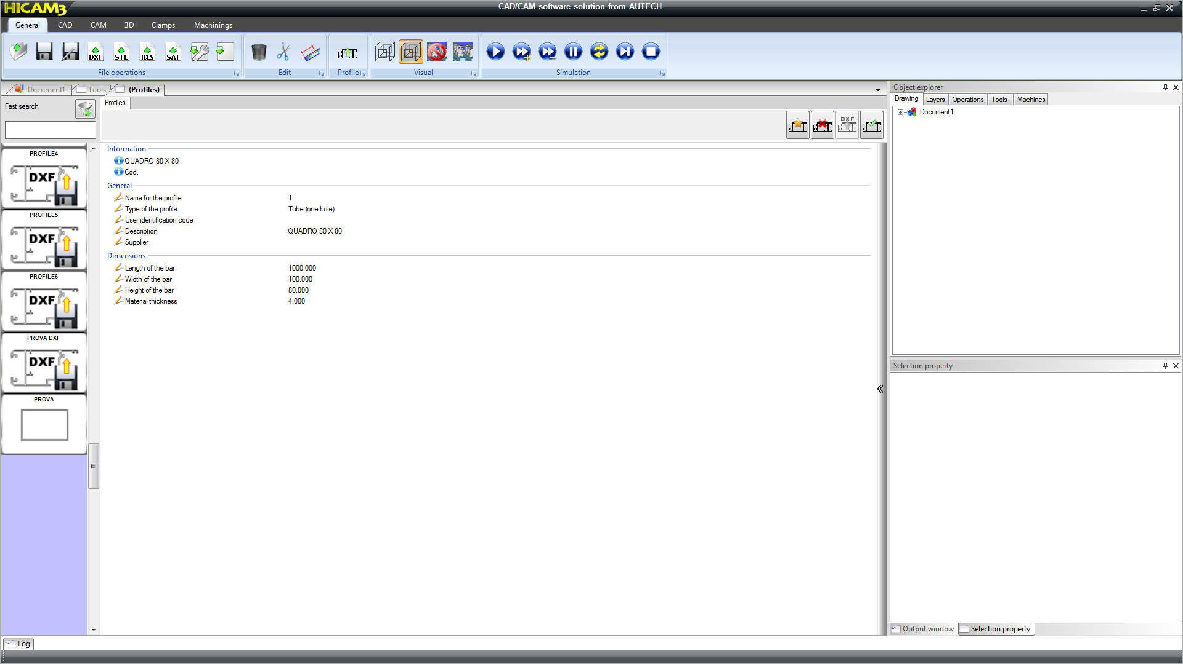

Profiles
This is the main Profiles configuration window. All profiles which may be used to generate any machining must be previously declared here.
To manage the profile catalog, use the 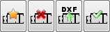 buttons that are:
- Create new profile
- Delete selected profile
- Load a 2D section from a DXF file for the current profile
- Use the selected profile to create a new program

Creating a new profile
Select the Create new profile icon then fill in the information about the profile:
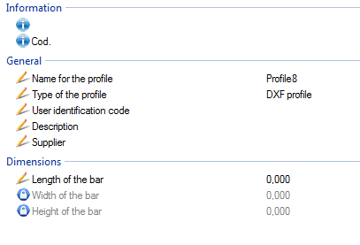
When “DXF profile” is selected as Type of the profile, the only dimension requested is the length (width and height are automatically imported from de DXF file, then use 1:1 scaled DXF).
You can choose from different types of profiles, then different information will be requested, as shown here:
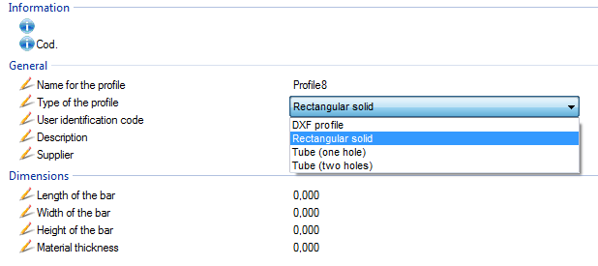

Creating a new document from a profile
Choose a profile or create it in the Profile window as shown in the previous section.
Then use the icon to confirm. A new document using the selected profile will be created:
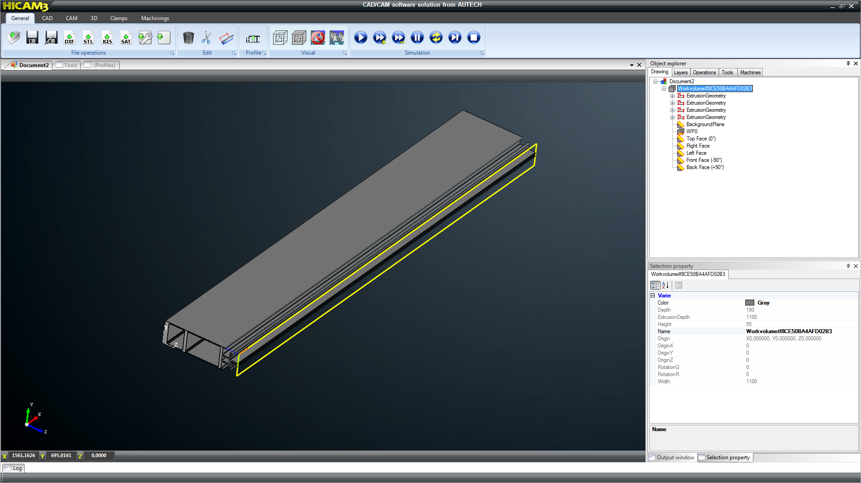

In the General menu a Profile section is available with the following functions:

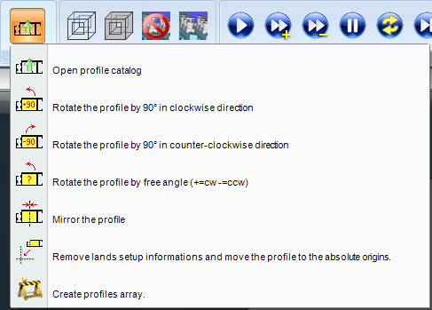

Creating machinings on a profile
In order to create machinings on a profile in a document, you have to select the tool you want to use in the Tools window, first (for further details about tools, refer to section 5.8 and section 6.4.1).
Then activate the tool:
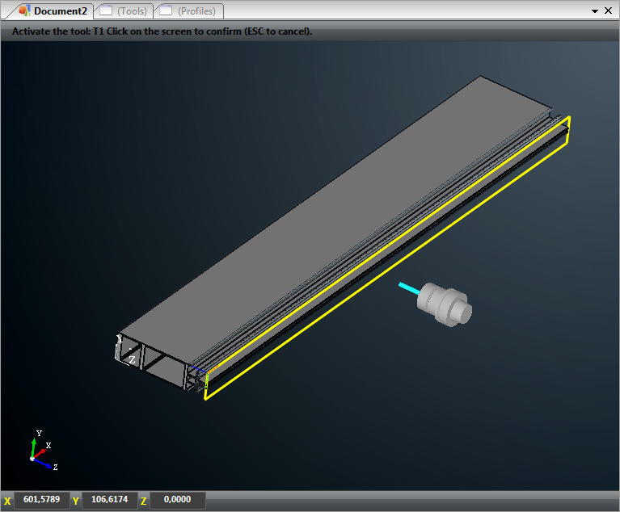
Select the face you need to work on in the Object explorer>Drawing, the selected one will be yellow highlighted:

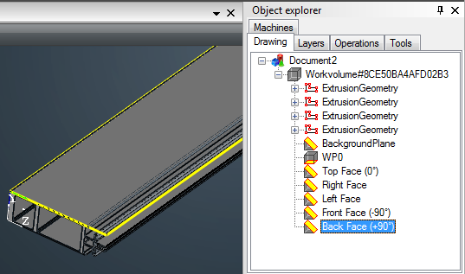
Now you can select the Machinings menu to choose the machinings.

The Machinings menu
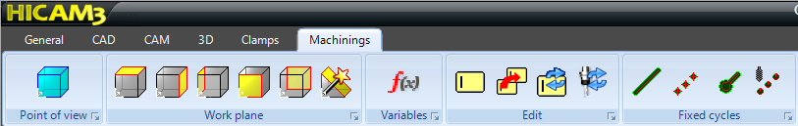
Fixed cycles machinings: each icon contains a menu to select machinings from

Viewpoint setting: these commands set the viewpoint to be orthogonal to the 6 standard WorkVolume faces, to current WorkPlane or a perspective 3D view.

Edit machinings: enables to edit existing machinings

Work planes selection: see section 6.3.3

Variables editor: you can create you own variable and assign them values, to parameterize your program

In the Fixed cycles section you can choose:
- Linear milling
- Multiple linear boring
- Multiple circular boring
- Keyhole
- Hole by 4 points (fillet and full fillet)
- Rectangular hole with rounded corners
- Multiple linear tapping
- Multiple circular tapping

In the Edit machinings section you can choose:
- Edit machining parameters
- Clone one existing machining to the current workplane
- Move an existing machining to the current workplane
- Use current tool for one existing machining

Adding a Linear milling (example)
As an example select Linear milling in Fixed cycle. All the other machinings selection will work in a similar way.
You will be requested the machining parameters:
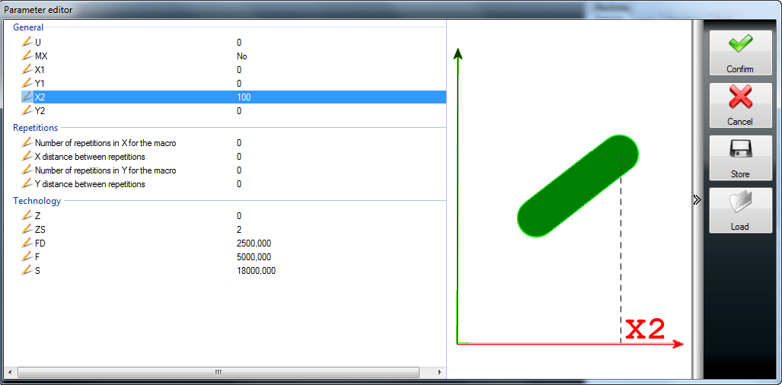

Selecting each parameter, you will be showed the meaning of it in the figure on the right hand side.
You can use formulas to create a parameterized machining using variables set in the variables editor (see chapter 8 “Hicam3 parametric functions” for further details).
You can store the machining in a file ad use it again loading it in any program you create.
To add this machining click on Confirm.

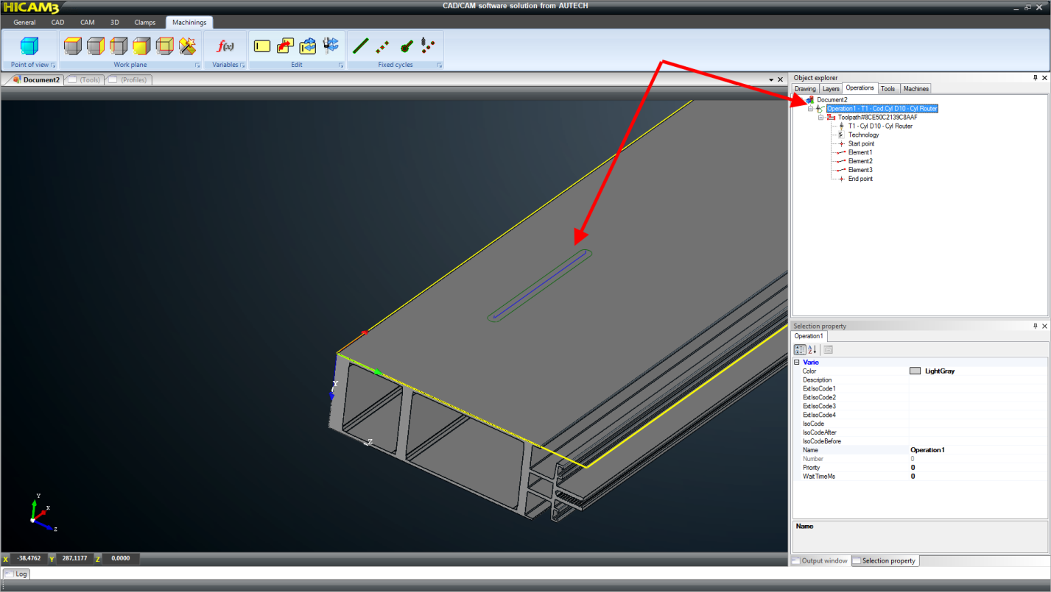
The new machining will be drawn on the profile and added in the Operations section of the Object explorer.
Once the document is completed, save it into a file using the Save button in the General menu.
You will be prompted a name for the document to save.

If you want, you can simulate the machining(s) by clicking on the play button in the Simulation section in the General menu:
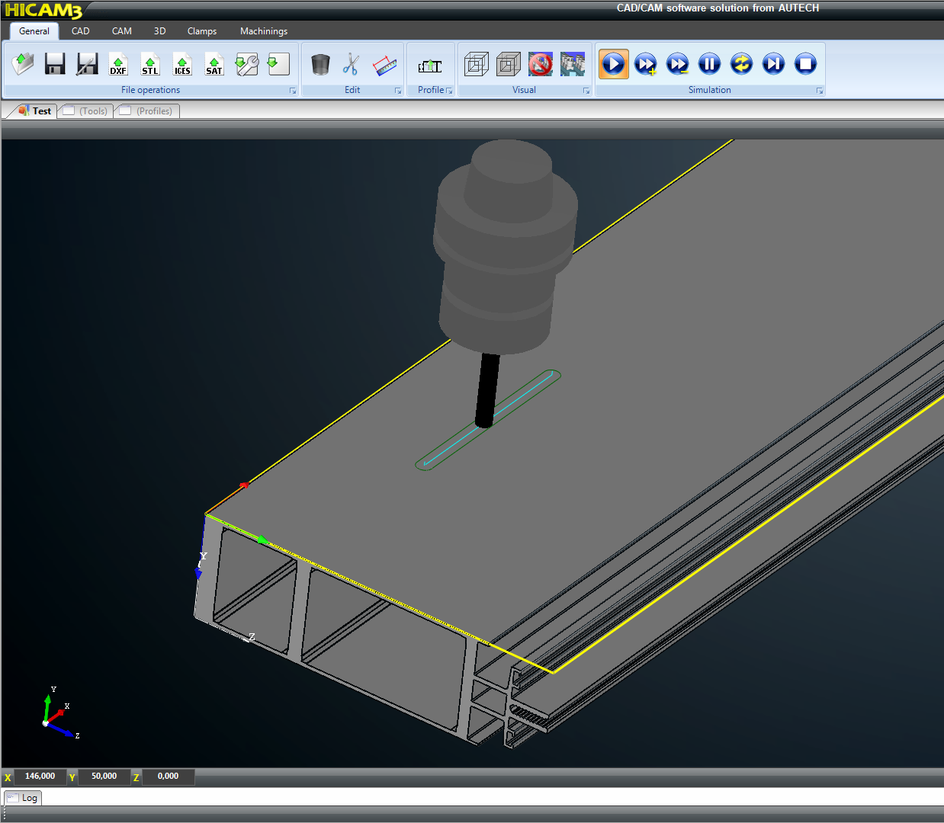

From drawing to ISO for CNC machine
Once you have created your document (drawing) you need to transform it into something that you CNC machine can handle.
There are a few easy steps you need to follow. They will be explained in the following sections.

Setting the machine configuration
In order to create an executable program on a machine (ISO) you first need to set up the machine configuration. Select the General menu and click on the Machine lands setup icon:

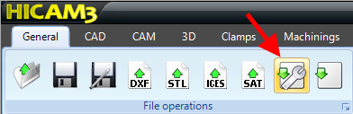

If your document has not been saved yet, save it when you are be asked to.
The configuration window will open:
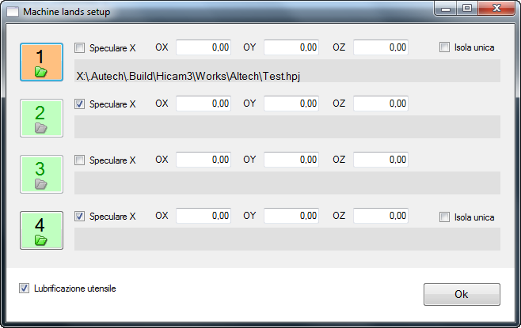

The four numbered buttons represent the machine lands on which you can clamp the workpiece you are going to work. Only the available lands are enabled.
In the example in the figure land1 has been selected and the document saved as “Test” has been located there (once you have clicked on one of the land-buttons you are asked which document to load).
You can add a document on each available land, the configuration will allow you to generate a unique program to execute each document you added.
You can provide XYZ offsets if needed, check the Mirror X option to mirror the program, and check if you want to use the machine as a unique land.
Tool lubrication on/off option is also available.

Click on Ok to proceed.

In order to view the workpiece as it appears on actual machine, click on the 3D machine model icon in the General menu:

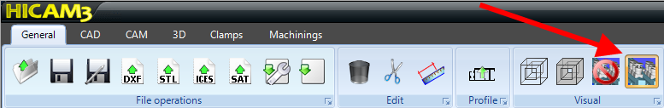

This is what you get:

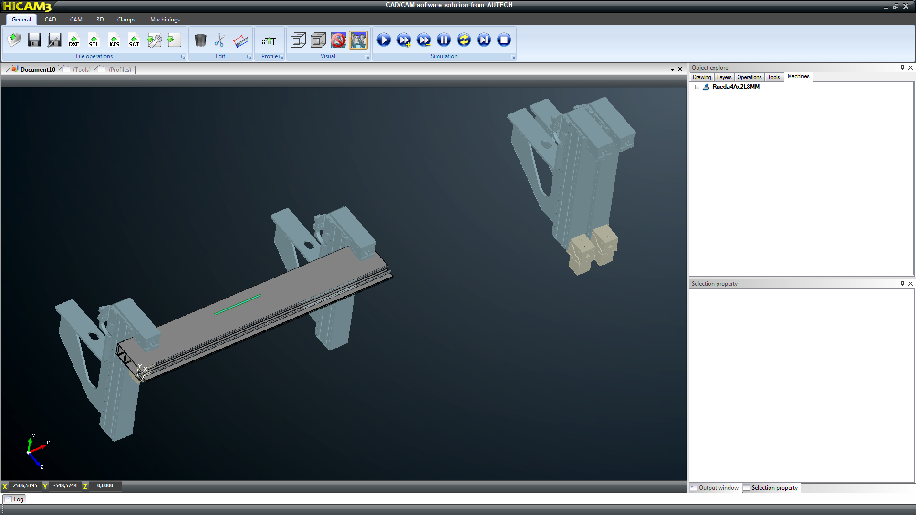

Setting clamps position
In order to set the clamps position select the Clamps menu and then click on the clamps positioning icon :
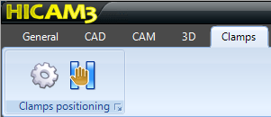

Automatically the 3D machine model will be enabled, and the prohibited zones for clamps as well (highlighted in red on the profile – i.e. you cannot put any clamps on the red range or you will get a collision with the spindle while executing the program).

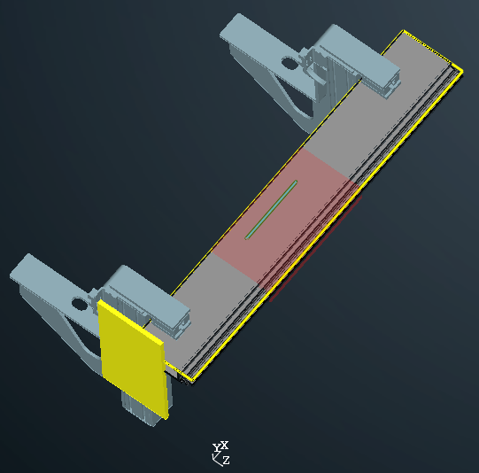
The clamps window opens:

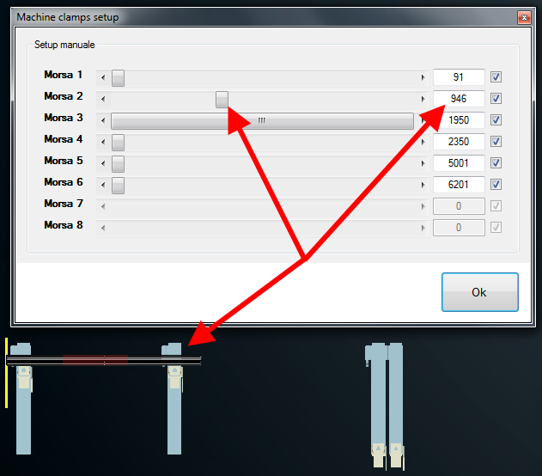

The clamps available on the actual machine are enabled to be placed dragging the scroll bars or writing the quote. The check box is used to select which clamps you want to move, leaving the others in the previous position on the machine (when possible). Any change to the values will be shown in the 3D model (in the last figure Clamp2 has been placed in position 946mm on the machine).

Click Ok an you will be prompt if you want to add a new Operation at the beginning of the file. Click on yes and the operation of setting the clamps position on the machine will be the first step in the program executed on the CNC machine:
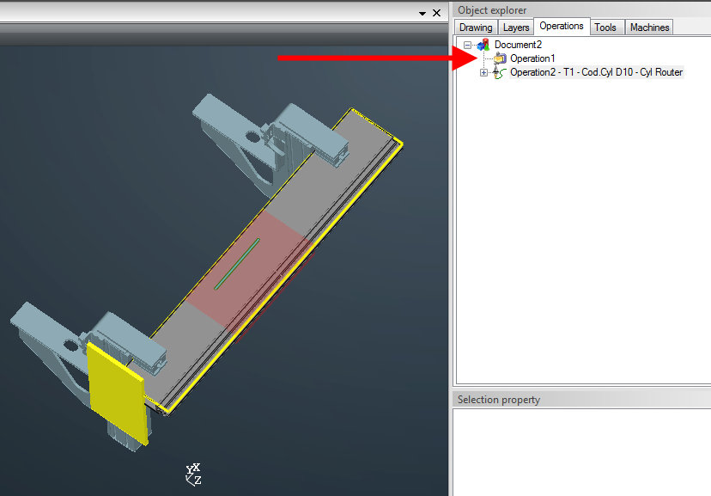

You can also change the clamps position during a program execution by adding new clamps positionings in the same way of the first one just added. Be careful and watch the operations sequence in the Operation tree of the Object explorer. You can change the operations order of execution right-clicking on the operation you want to move:

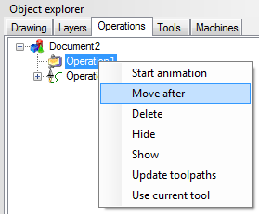

You can also enable/disable the prohibited zones and the 3D machine model views from the General>Visual menu (last two icons, now highlighted showing they are both enabled):

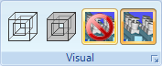

Simulating a program
If you want to check what you have done you can simulate the program pressing the play button on the Simulation section in the General menu:
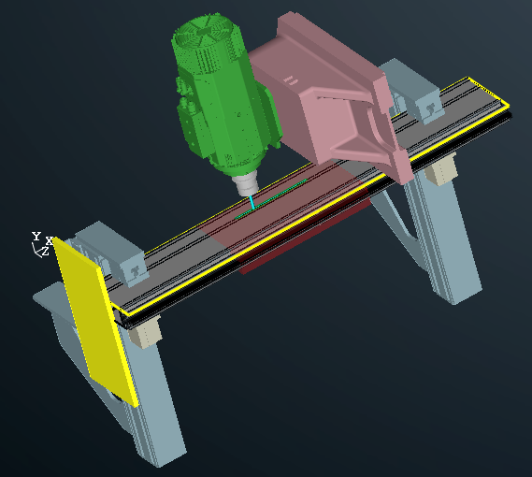

Creating the ISO file for the CNC machine
The last step is to generate the ISO file executable by the CNC machine.
Simply press the Machine code generation icon in the General menu:

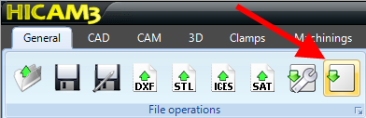

When the ISO file is ready you will be prompted a message and the ISO code can be read in the Output window:
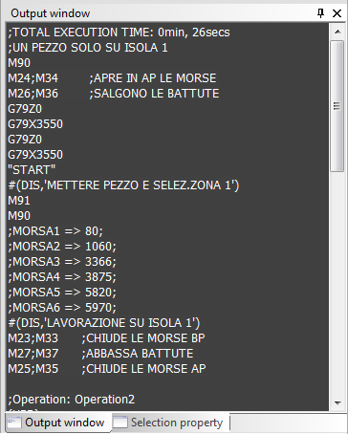

It is now possible to execute the generated program.

APPENDIX – HICAM3 PARAMETRIC FUNCTIONS

PREDEFINED CONSTANTS:
Name : PI
Description : returns the PI value (3.1415926535897932384626433832795…)

Name : E
Description : returns Euler’s number (2.71828182845904523536028747135…)

PREDEFINED VARIABLES:
Name : DX (o DX1, DX2, DXn, etc..)
Description : returns X dimension of WorkVolume “n”

Name : DY (o DY1, DY2, DYn, etc..)
Description : returns Y dimension of WorkVolume “n”

Name : DZ (o DZ1, DZ2, DZn, etc..)
Description : returns Z dimension of WorkVolume “n”

MATHEMATICS:
Function : ABS(x)
Description : gets the absolute value (unsigned) of “x” parameter
Examples : ABS(-3) = +3
: ABS(+3) = +3

Function : MIN(x;y)
Description : gets the minimum value between “x” and “y”
Examples : MIN(2;3) = 2

Function : MAX(x;y)
Description : gets the maximum value between “x” and “y”
Examples : MAX(2;3) = 3

Function : FIX(x) o INT(x)
Description : gets the integer part of “x”
Examples : FIX(2.345) = +2
: INT(2.345) = +2
Function : ROUND(x)
Description : gets the closest to “x” integer
Examples : ROUND(2.345) = +2
: ROUND(2.5) = +2
: ROUND(2.567) = +3

Function : COS(x)
Description : returns the cosine of the “x” angle in degrees “°”
Examples : COS(60) = +0.5

Function : SIN(x)
Description : returns the sine of the “x” angle in degrees “°”
Examples : SIN(60) = +0.866025

Function : ASIN(x)
Description : returns the arcsine of “x”
Examples : ASIN(1) = +90

Function : ACOS(x)
Description : returns the arccosine of “x”
Examples : ACOS(0.5) = +60

Function : EXP(x)
Description : returns the value of “E” (2,71828182845904…) raised to the power of “x”
Examples : EXP(2) = +7.389056

Function : LOG(x)
Description : returns the 10-based logarithm of “x”
Examples : LOG(2) = +0.301

Function : LN(x)
Description : returns the natural logarithm of “x”
Examples : LN(2) = +0.693

Function : SQR(x)
Description : returns the square root of “x”
Examples : SQR(2) = +1.414

Function : TAN(x)
Description : returns the tangent of “x” angle
Examples : TAN(30) = +0.577

Function : ATN(x)
Description : returns the arctangent of “x”
Examples : ATN(1) = +45

Function : SEC(x)
Description : returns the secant of “x”
Examples : SEC(30) = 1.155

Function : COSEC(x)
Description : returns the cosecant of “x”
Examples : COSEC(50) = 1.305

Function : COTAN(x)
Description : returns the cotangent of “x”
Examples : COTAN(5) = 11.43

Function : SGN(x)
Description : returns +1 when “x” is positive;
: -1 when “x” is negative;
: 0 when “x” is null;
Examples : SGN(+7) = +1
: SGN(-4) = -1
: SGN(0) = 0

CONDITIONALS:
Function : IF(x;y;z)
Description : returns “y” if “x” is not zero or “z” if “x” is equal to
Examples : IF(1;4;6) = 4
: IF(3;5;10) = 5
: IF(-2;8;6) = 8
: IF(0;4;9) = 9

Function : NOT(x)
Description : returns 1 if “x” is not zero or 0 if “x” is equal to zero
Examples : NOT(7) = 0
: NOT(0) = 1

Function : OR(x;y)
Description : returns 1 if “x” or “y” are not zero
Examples : OR(2;0) = 1
: OR(0;3) = 1
: OR(2;3) = 1
: OR(0;0) = 0

Function : AND(x;y)
Description : returns 1 if “x” and “y” are both not zero
Examples : AND(2;0) = 0
: AND(0;3) = 0
: AND(2;3) = 1
: AND(0;0) = 0

Function : XOR(x;y)
Description : returns 0 if “x” and “y” are both not zero or both equal to zero;
: returns 1 in all other cases;
Examples : XOR(2;3) = 0
: XOR(0;3) = 1
: XOR(2;3) = 1
: XOR(0;0) = 0

